# **Linear Classifiers**

## **Restaurant Review System**

The review is from a customer who likes Sushi.  
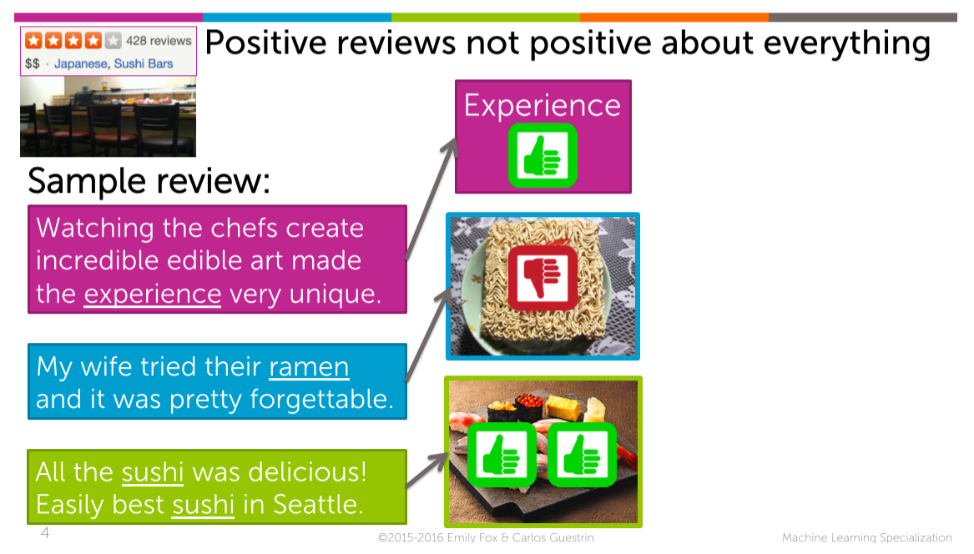

Every review has a different aspects and different sentences.   
I would like to capture a sentiment of each sentence so I can understand if it’s good with respect to Sushi which is what I care the most.

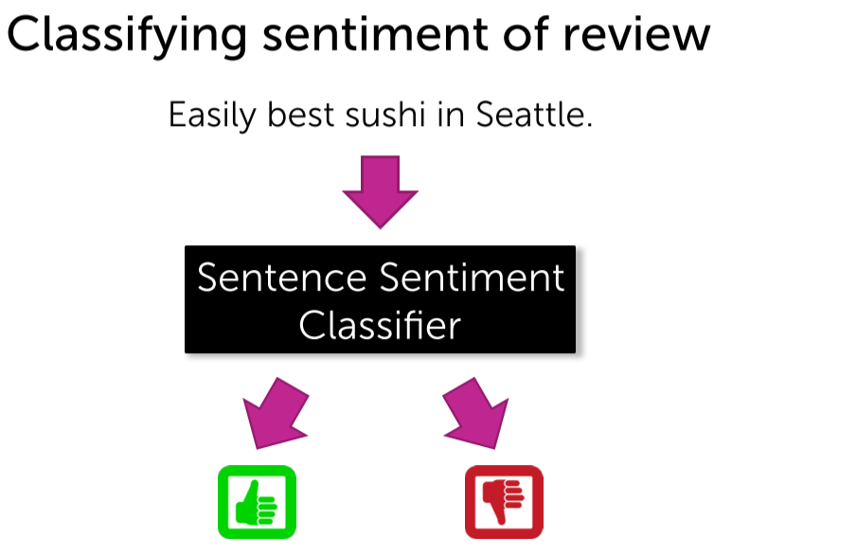

## **Intuition behind Linear Classifier**

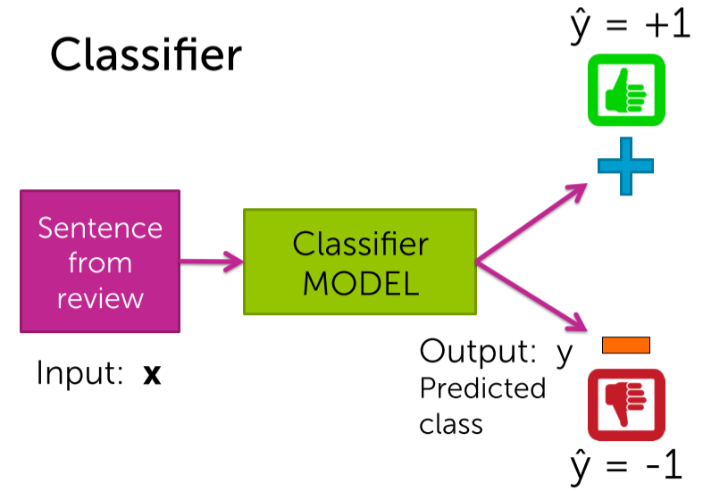

How positively/negatively influential this word is ??

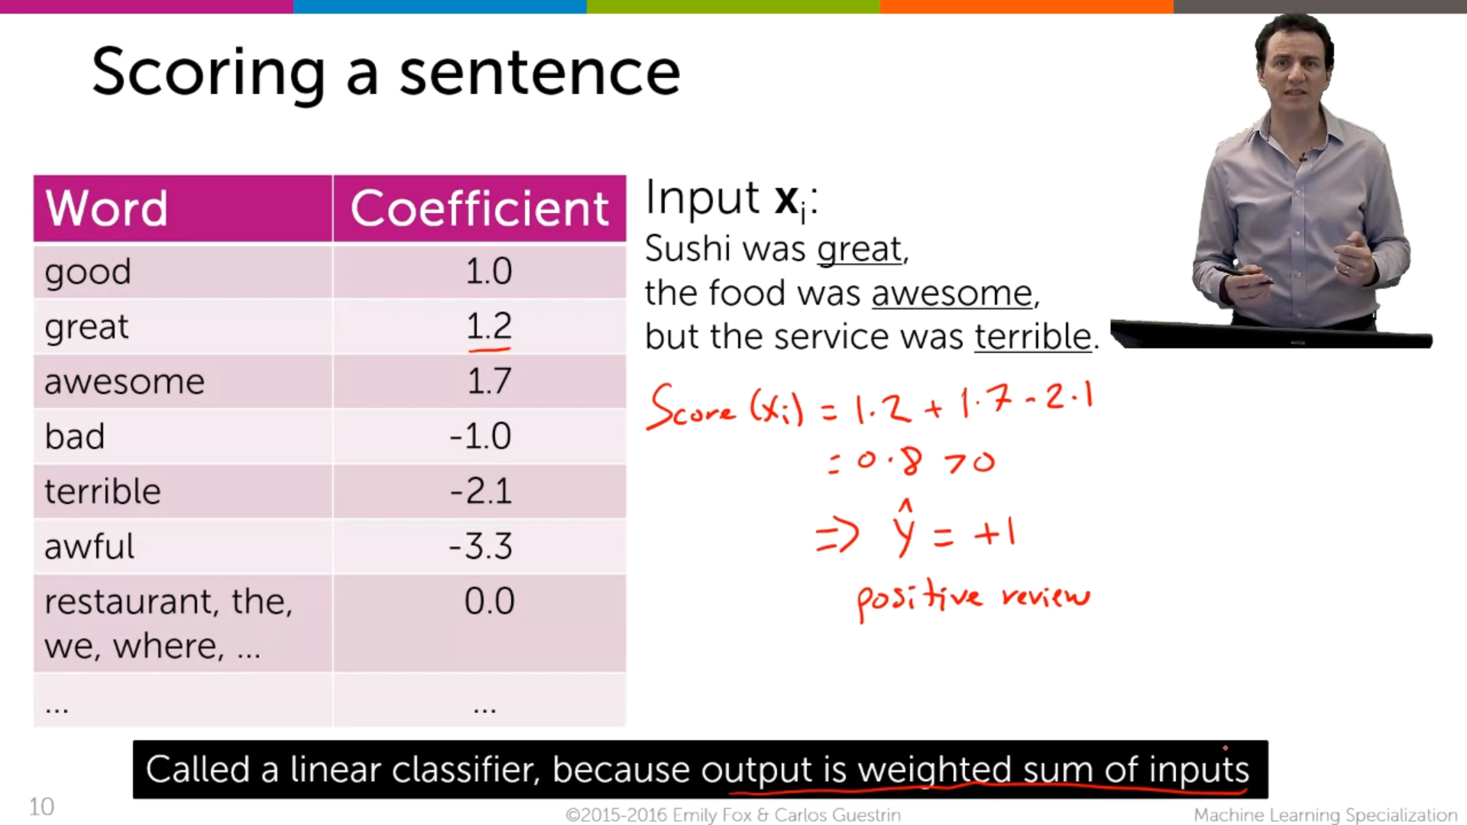

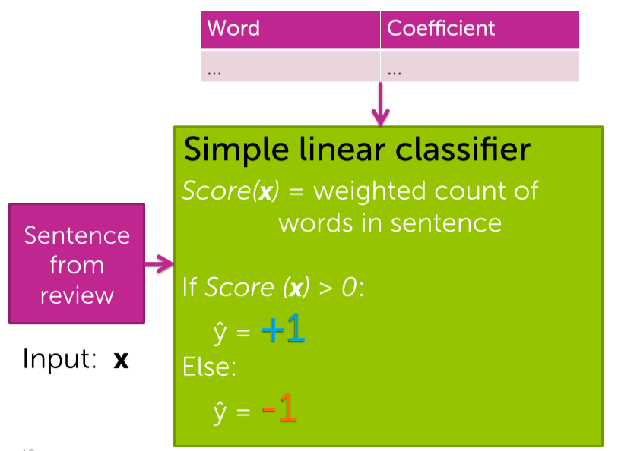

It is the more simplified model for simple linear classifier.

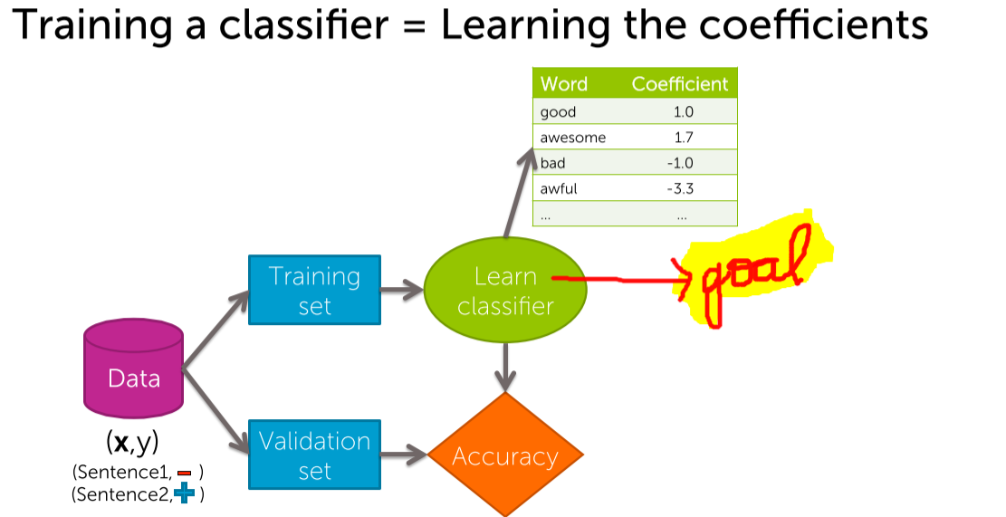

## **Decision boundaries**

Every word has coefficient 0 except #awesome and #awful

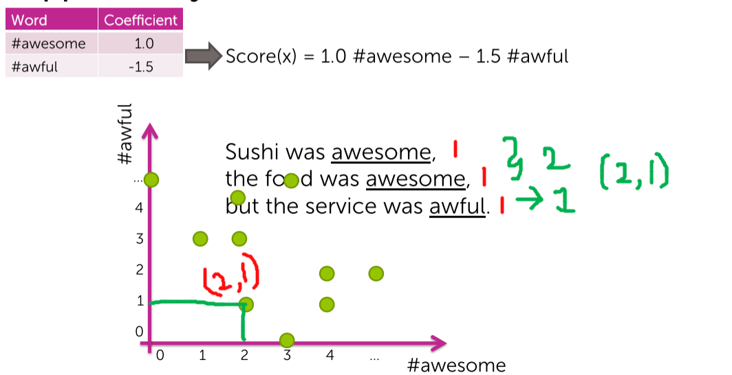

(2 awesome’s ,1 awful) 🡪 plotted.  
Similarly all the data-points are plotted from the data-sets with our fixed coefficient.

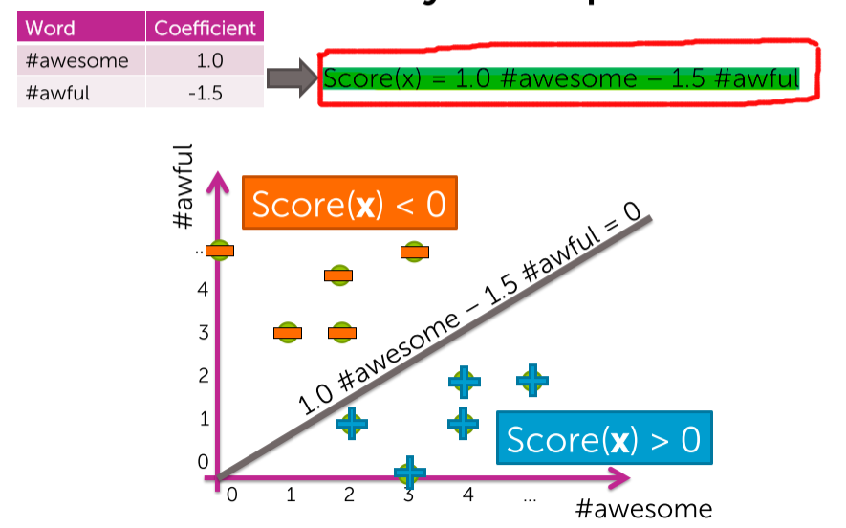

The classifier which we have trained from the data-sets with the coefficients 1.0 and -1.5 will have the decision boundary corresponding to a line.  
1.0#awesome – 1.5#awful = 0  
Score(x)>0 [ below the line ] 🡪 +ve review  
Score(x)<0 [ above the line ] 🡪 -ve review

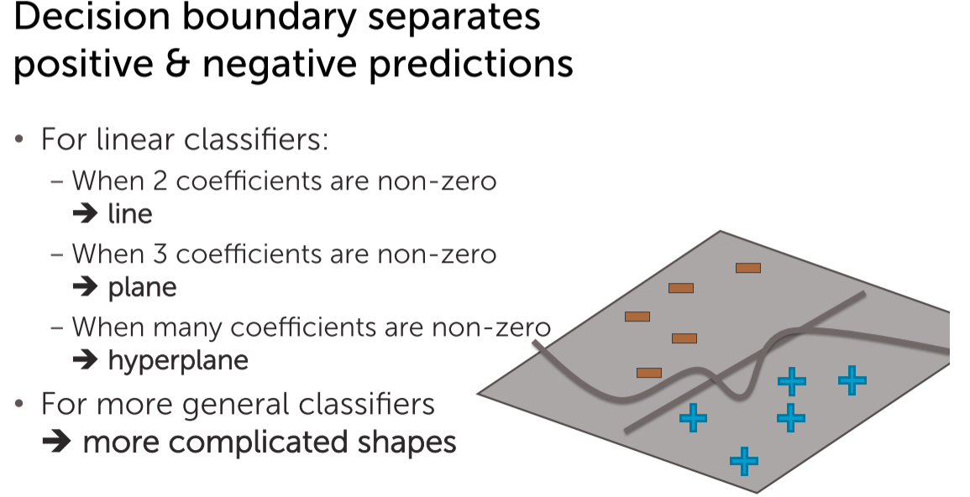

## **Linear classifier Model**

A linear classifier model will try to build a hyper plane (green surface) that tries to separate the positives from the negative examples.  
The hyper plane is associated with the score function i.e Score(x).

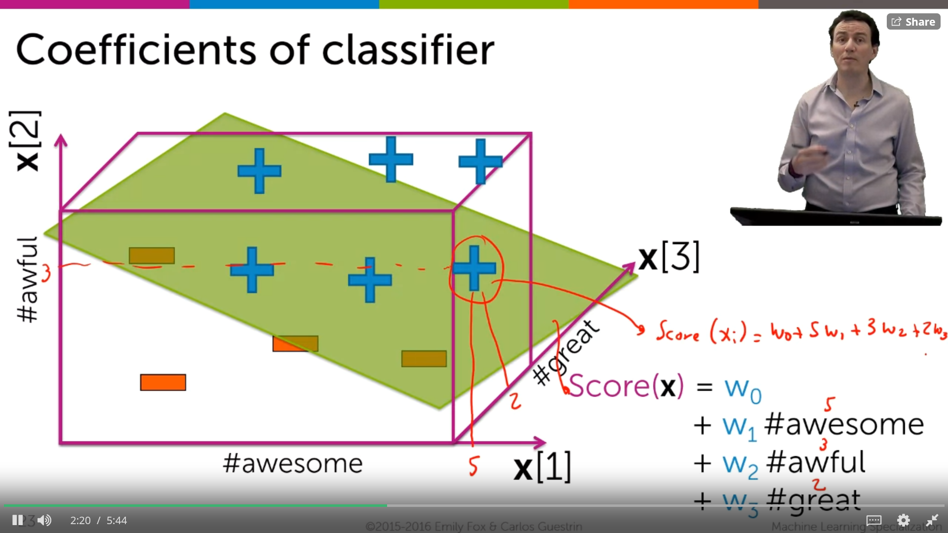

Depending upon the coefficients the score may be +ve/-ve. Since this is a positive training example we want to choose the w that makes the score positive.

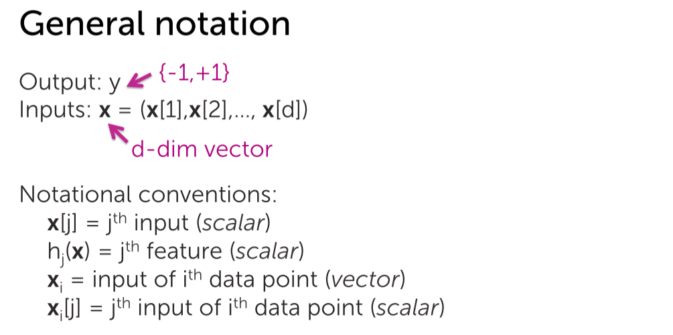 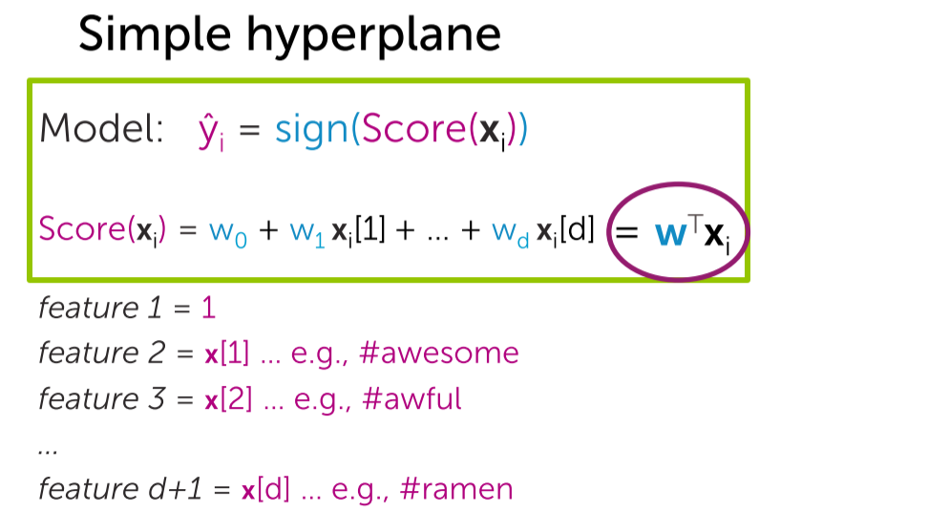

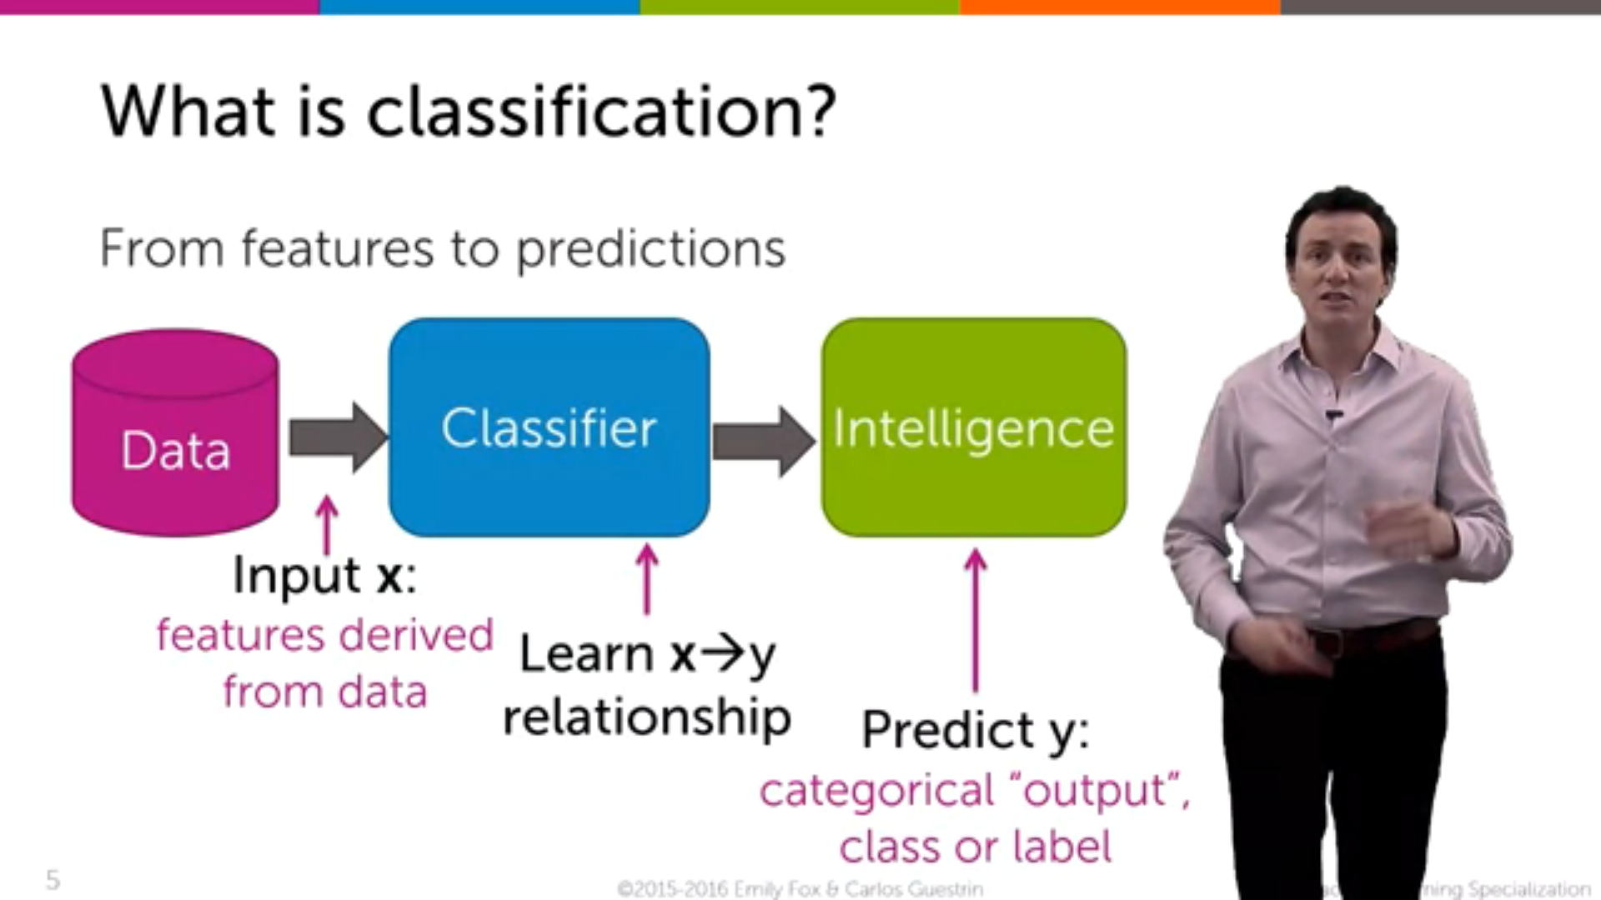

**Multi-class classification**

Given a web page, we have to find out whether that page belongs to ‘Education’, ‘finance’, ‘technology’ based on the content of that webpage.

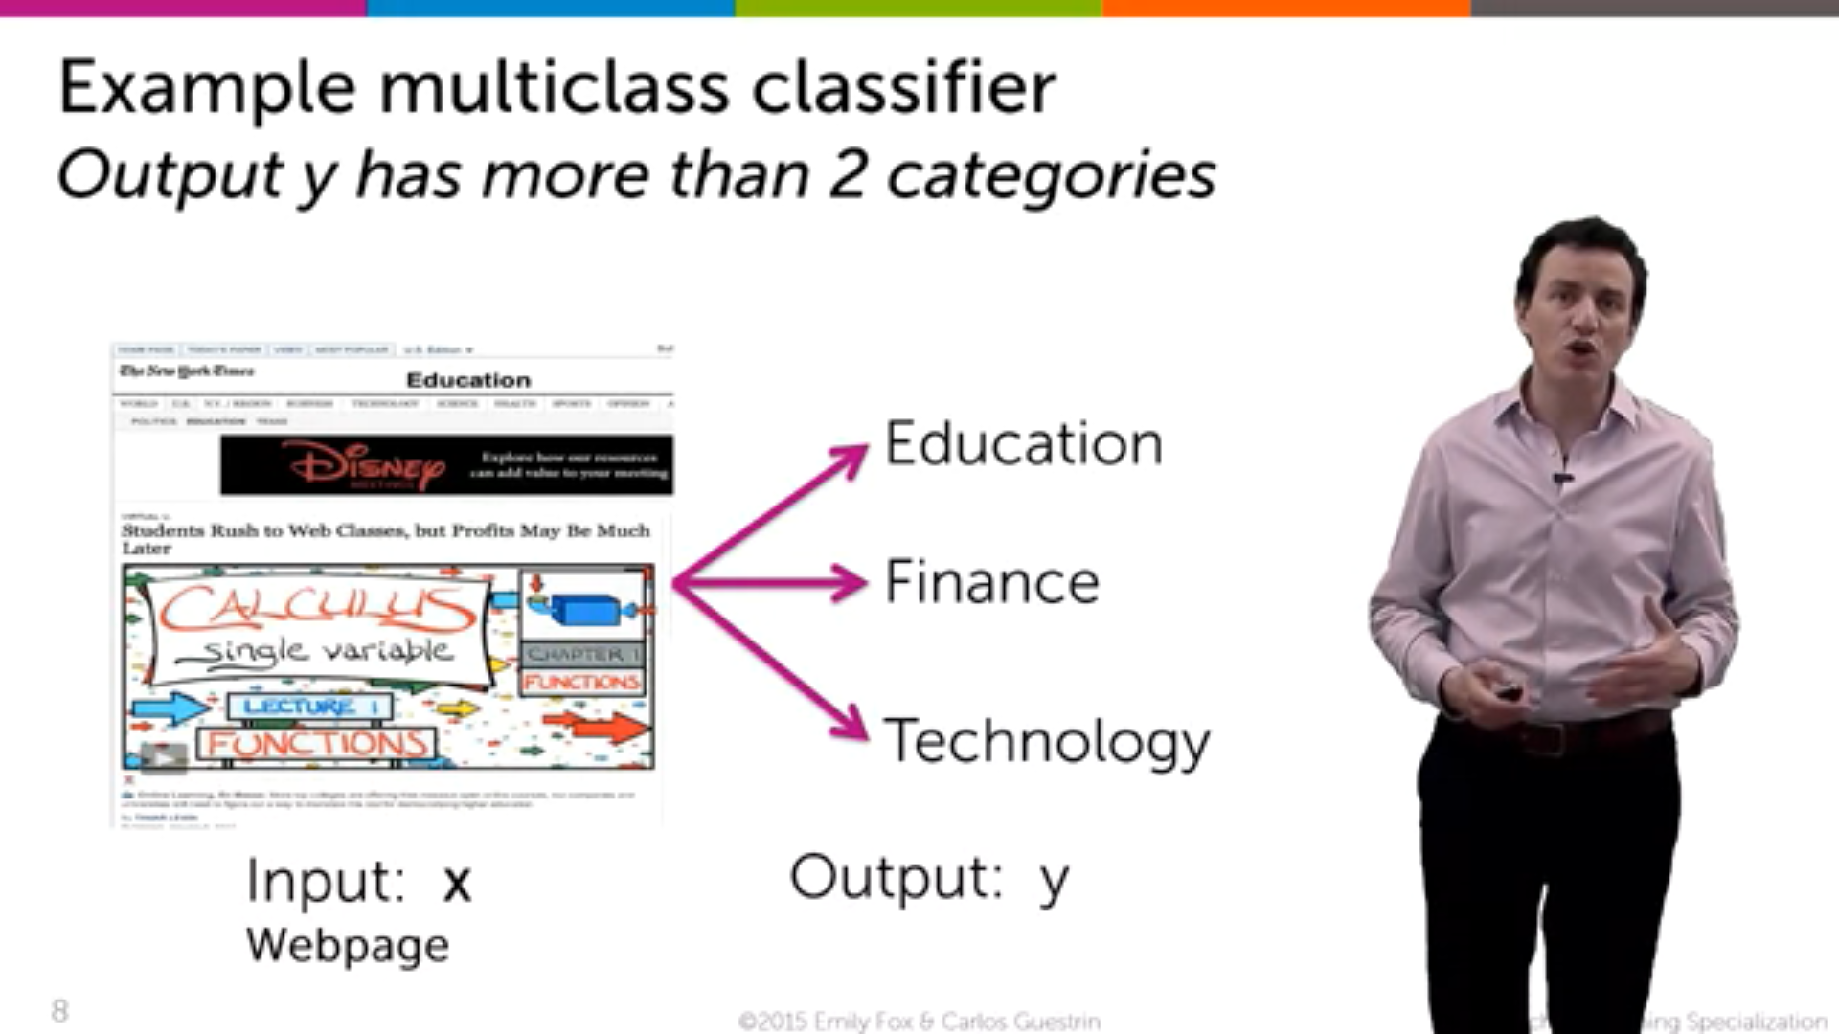

**Famous Example** : Spam filtering

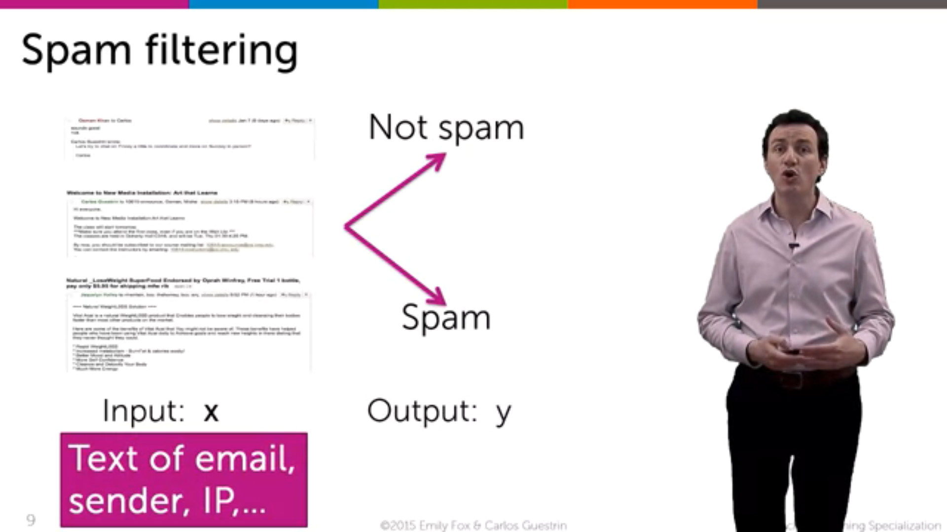

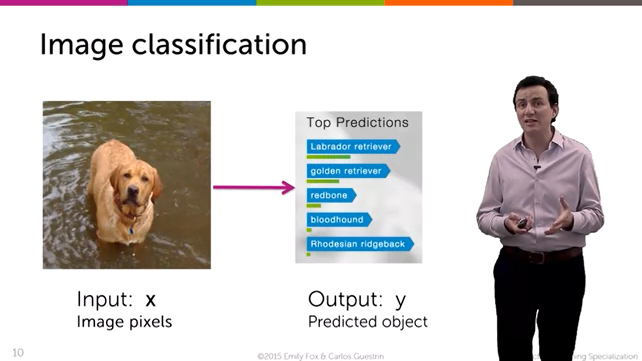

This classifier is for all the patients ir-respective of their personal habits

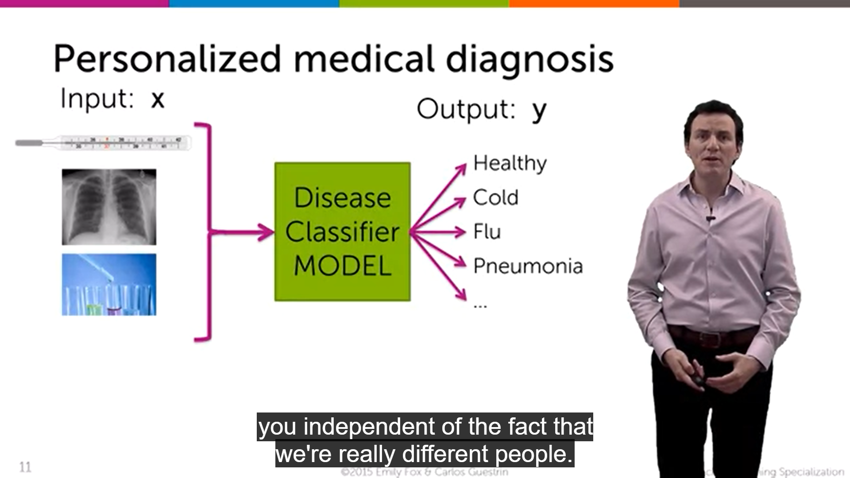

But personalized medical diagnosis tests our DNA, food-habits, genetical problems, total body metabolism etc to decide what treatment is going to be most effective for that individual person instead a giving a routine flat general treatment.

This is the real world example of classification problem.

**Mind-Reading :**

A person sees an hammer. A FMRI is taken for that particular person, From that Scanned images we can conclude that what a person is seeing whether an ‘hammer’ or a ‘house’

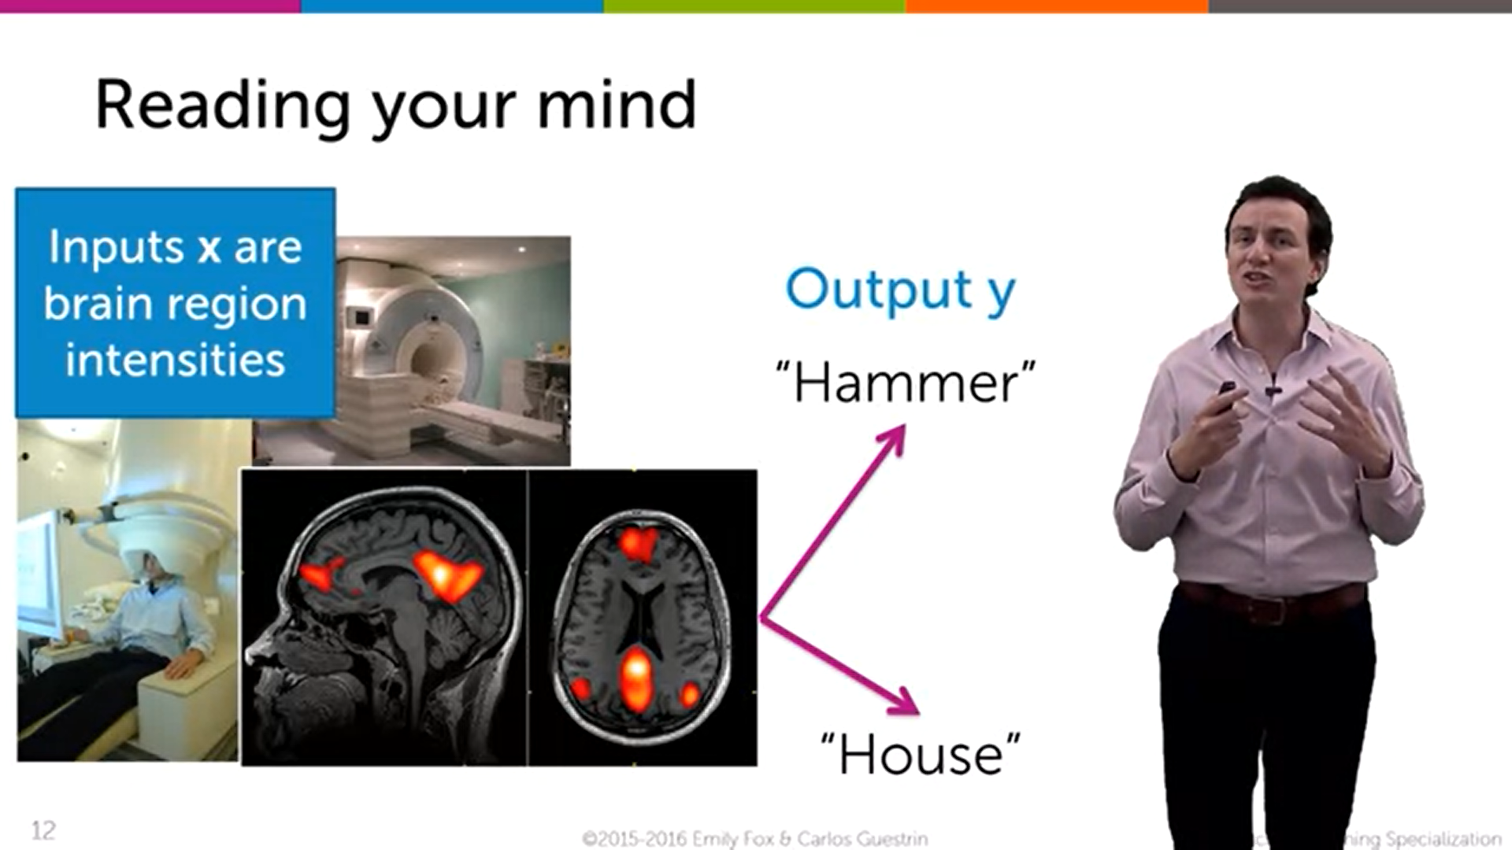

**Linear Classifier**

**1) Linear Classifier Model**

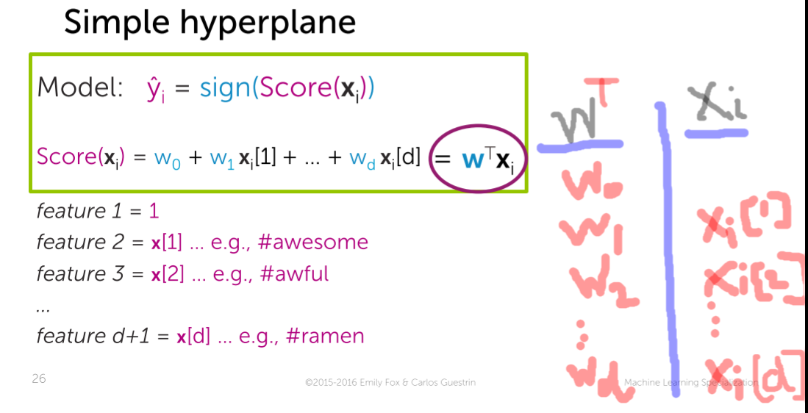



For a single row representing 🡪 xi   
Score for that single row 🡪 score(xi)  
Sign of the score of that single row 🡪 y^(i) = Sign(score(xi))

i from 1 to N (row wise) [xi]

**The Role of *sign***

If the score>0 then predict 🡪 +1

If the score<0 then predict 🡪 -1

At 0, we have the choice to predict either -1/+1. You make an arbitrary choice

**2) Effects of coefficient values on decision boundary**Initially the intercept 🡪 0

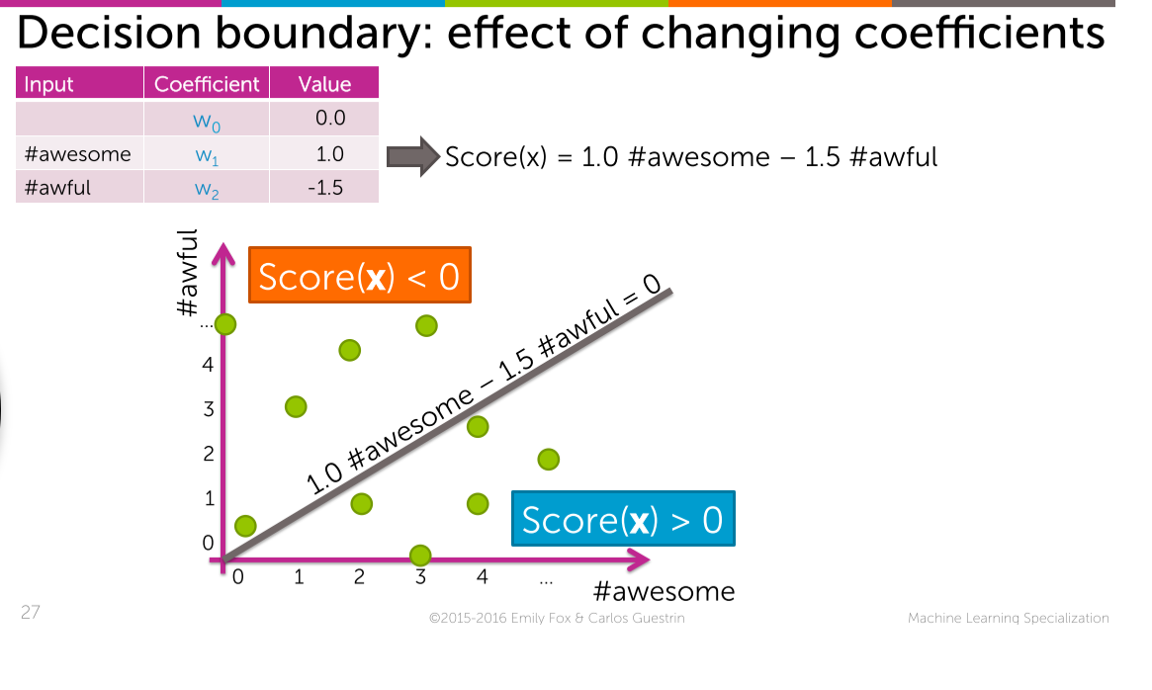



Now the intercept 🡪 1 and the line slightly shifts up, so the orange point which was -ve before, now becomes +ve

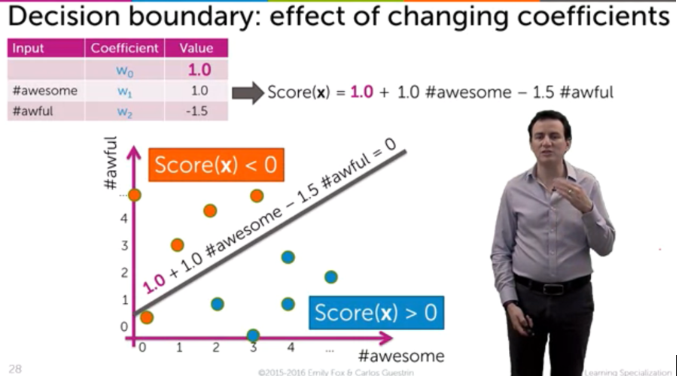



After changing the w2=-3.0, the line gets modified, and the blue point which was +ve Now becomes -ve.

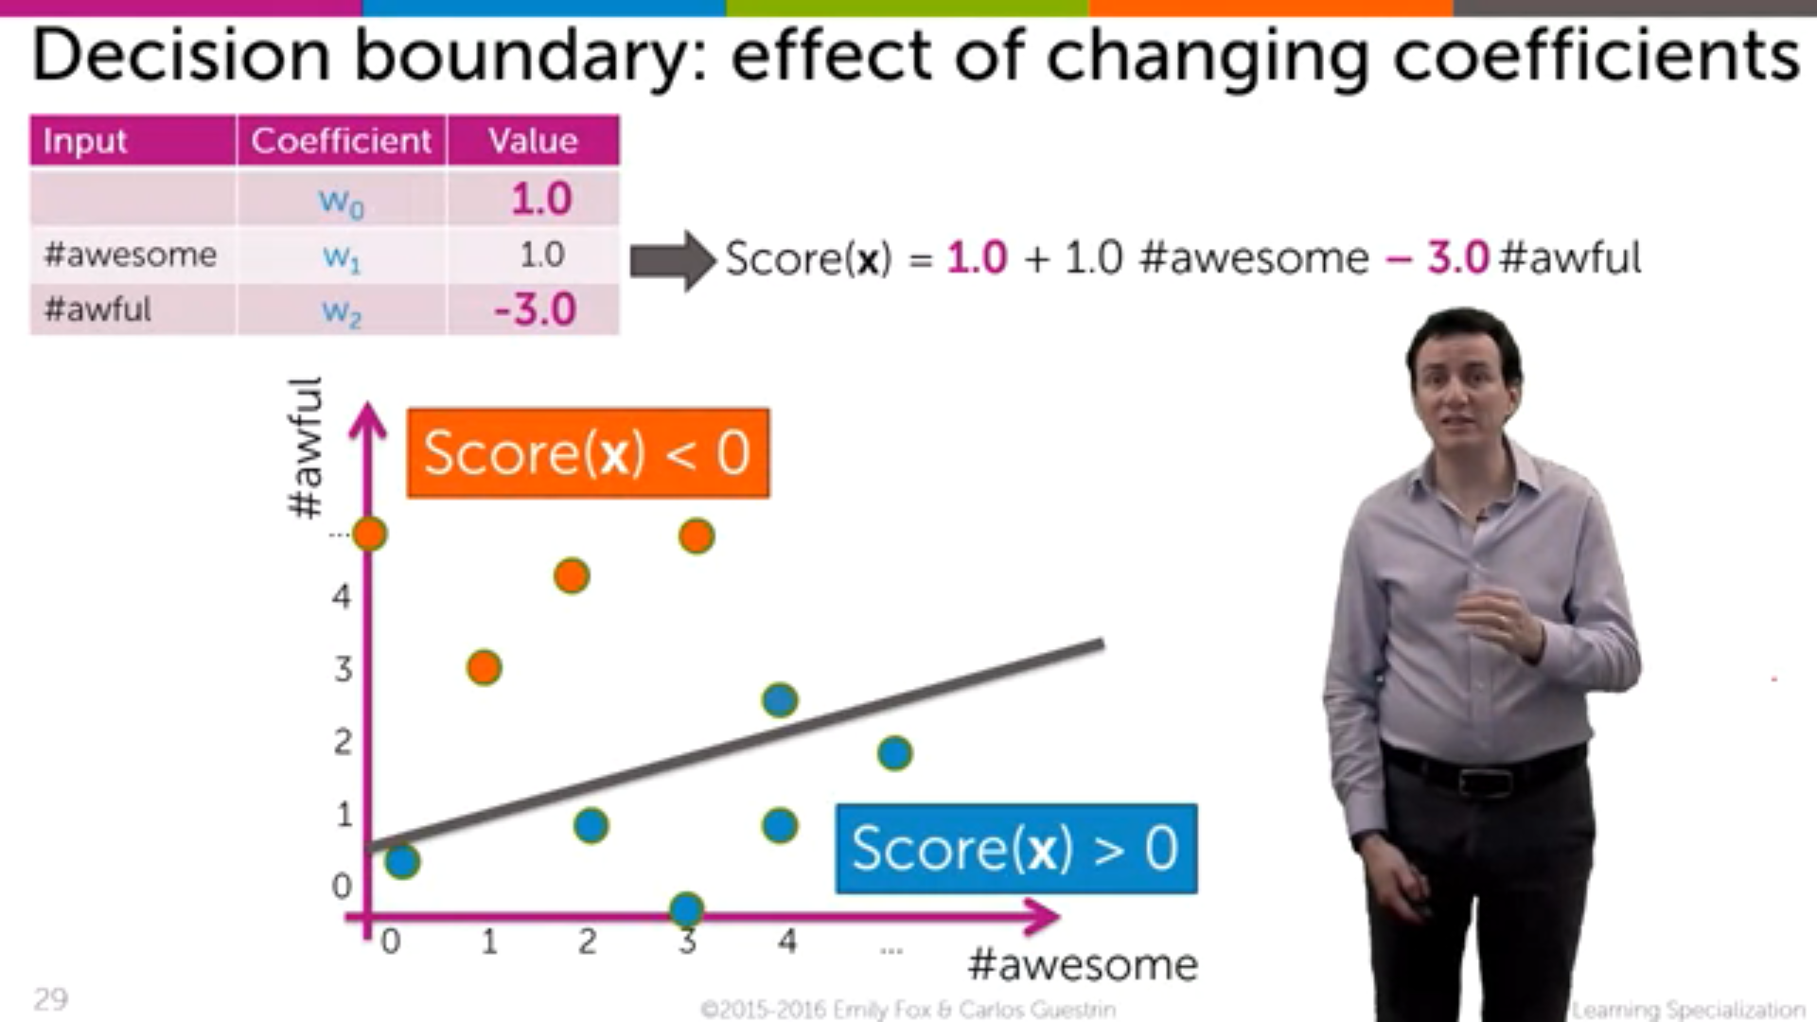



From this we can conclude that the coefficients are playing a very important role in the classification.

**3) Using features of inputs**

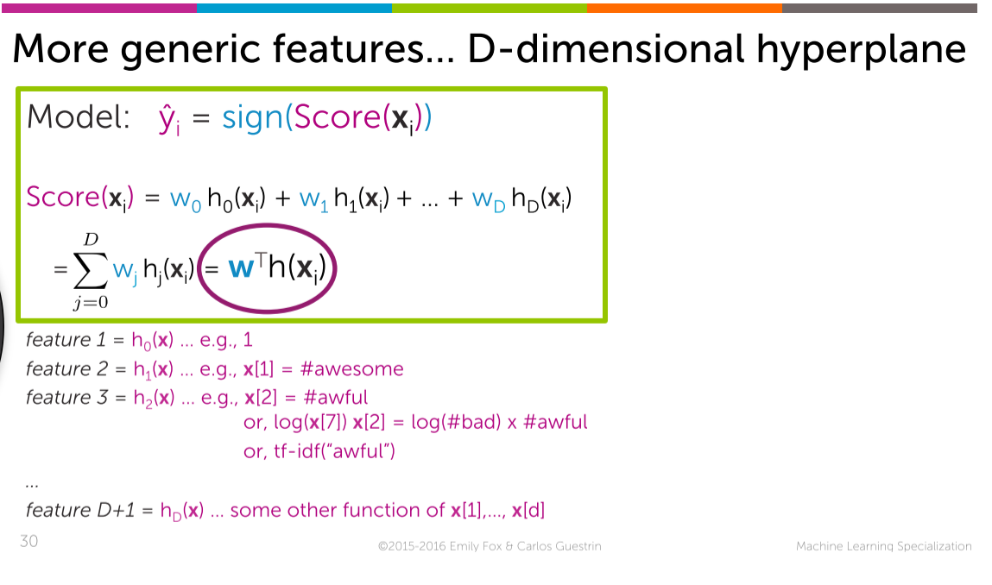

**Probabilities and its basics**

Not all our output will be exactly +1 or -1, especially the output of logistic regression will be like 0.432 (or) 0.211. So in-order to conclude them as +1 or -1 (Here probability comes into picture)

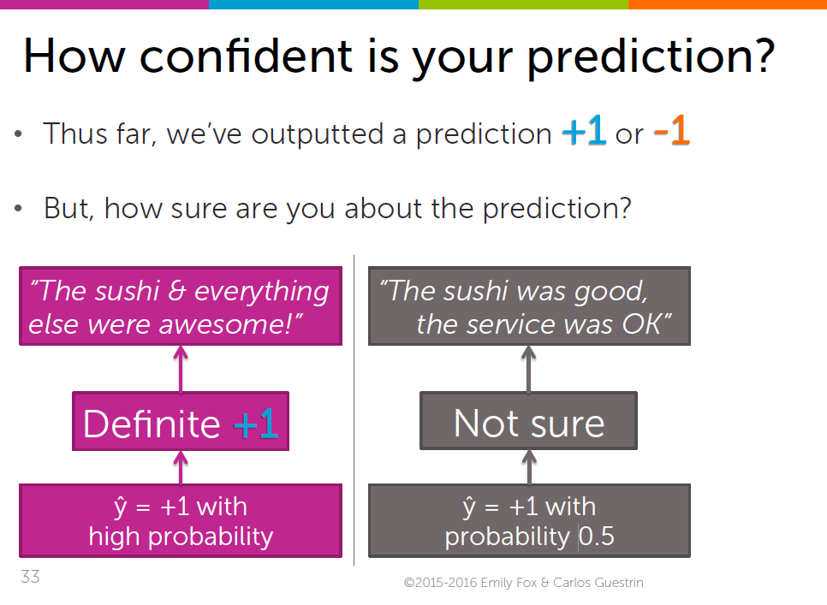

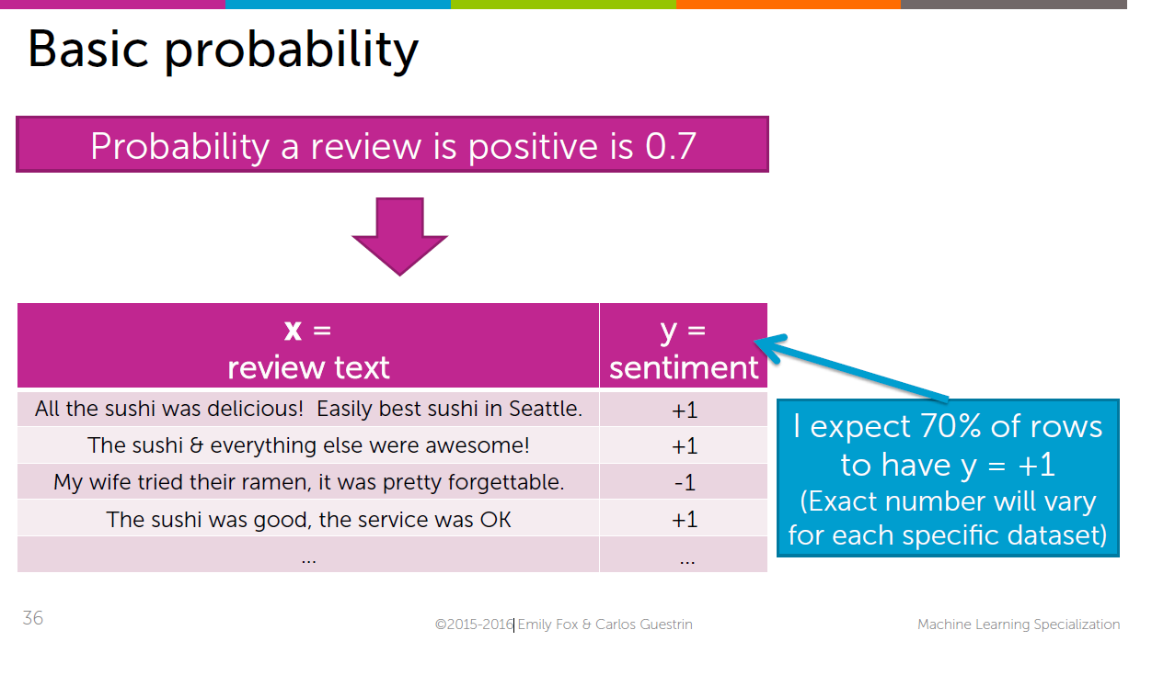

From the above it is assumed on an average,   
70% 🡪 +ve reviews and the   
remaining 30% 🡪 -ve reviews

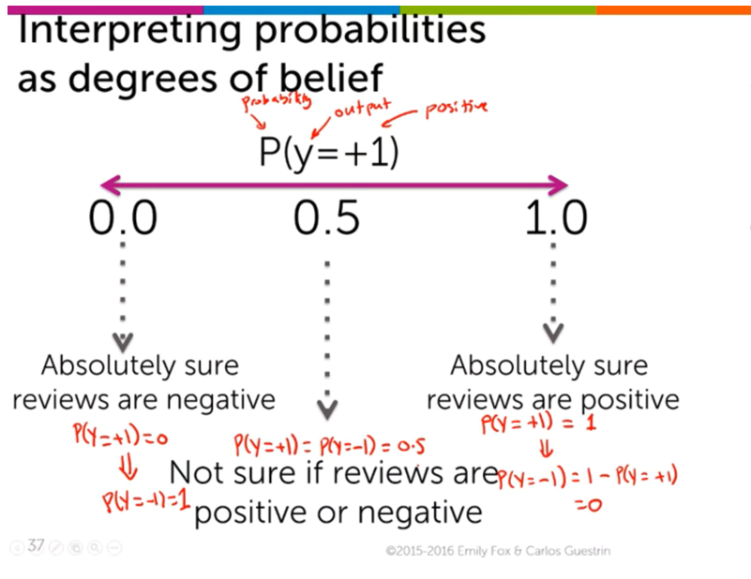

P(y=+1)->1[Complete +ve reviews],P(y=-1)🡪0 [No negative reviews]

P(y=-1)->1[Complete -ve reviews],P(y=1)🡪0 [No positive reviews]

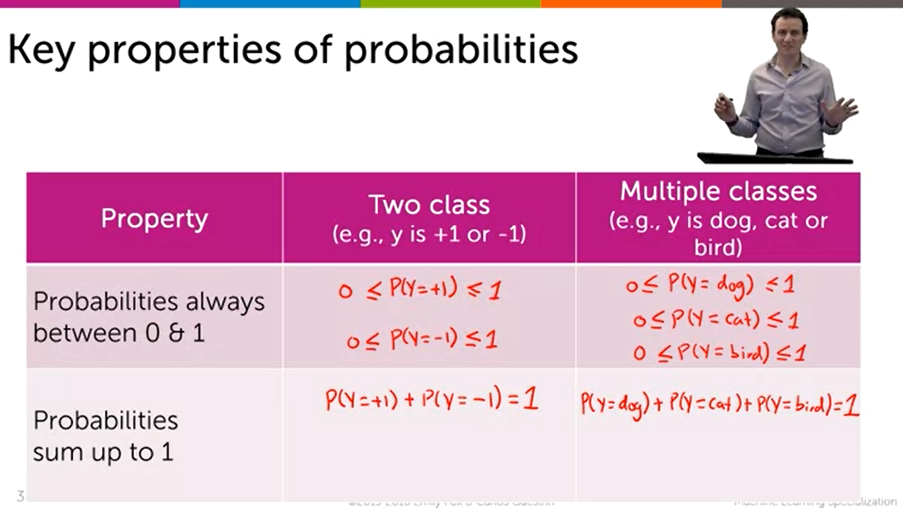

**Conditional Probability**

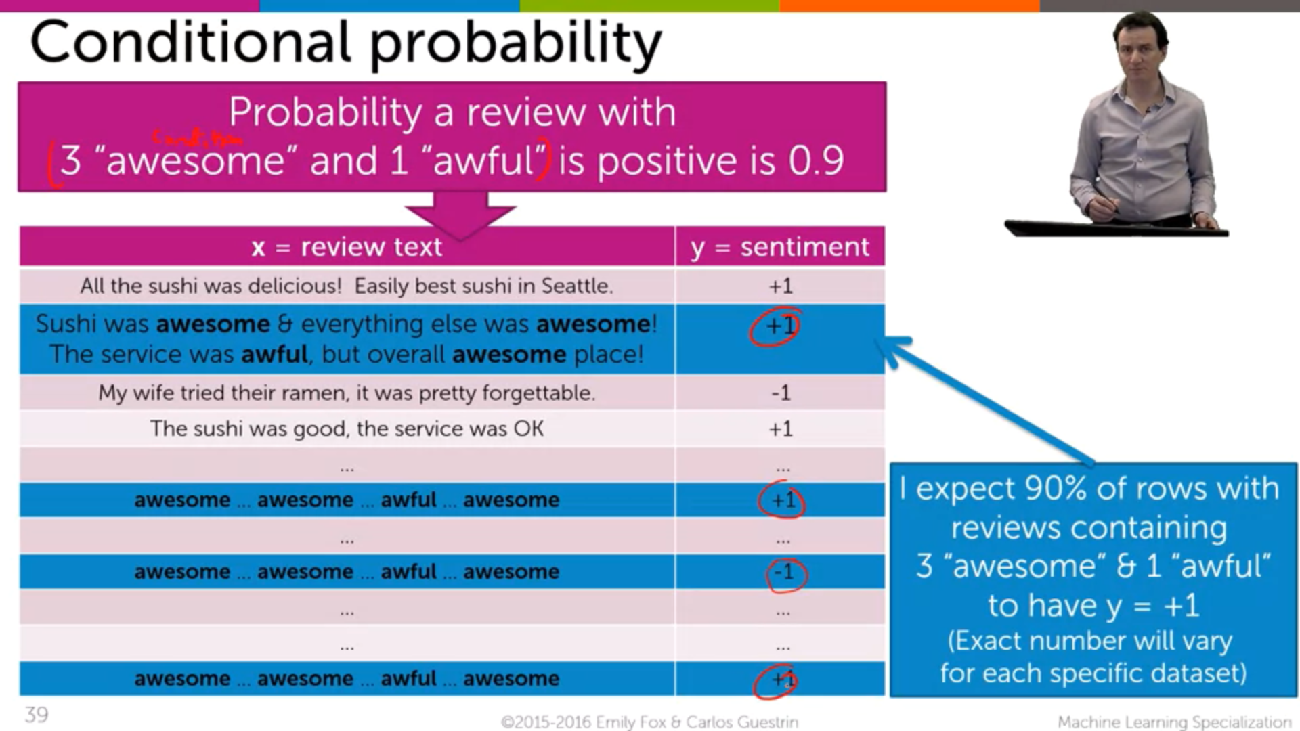

The given condition is that (“3 awesome and 1 awful”). In this given condition, it is observed that 90% of the reviews are +ve and the remaining 10% are -ve.

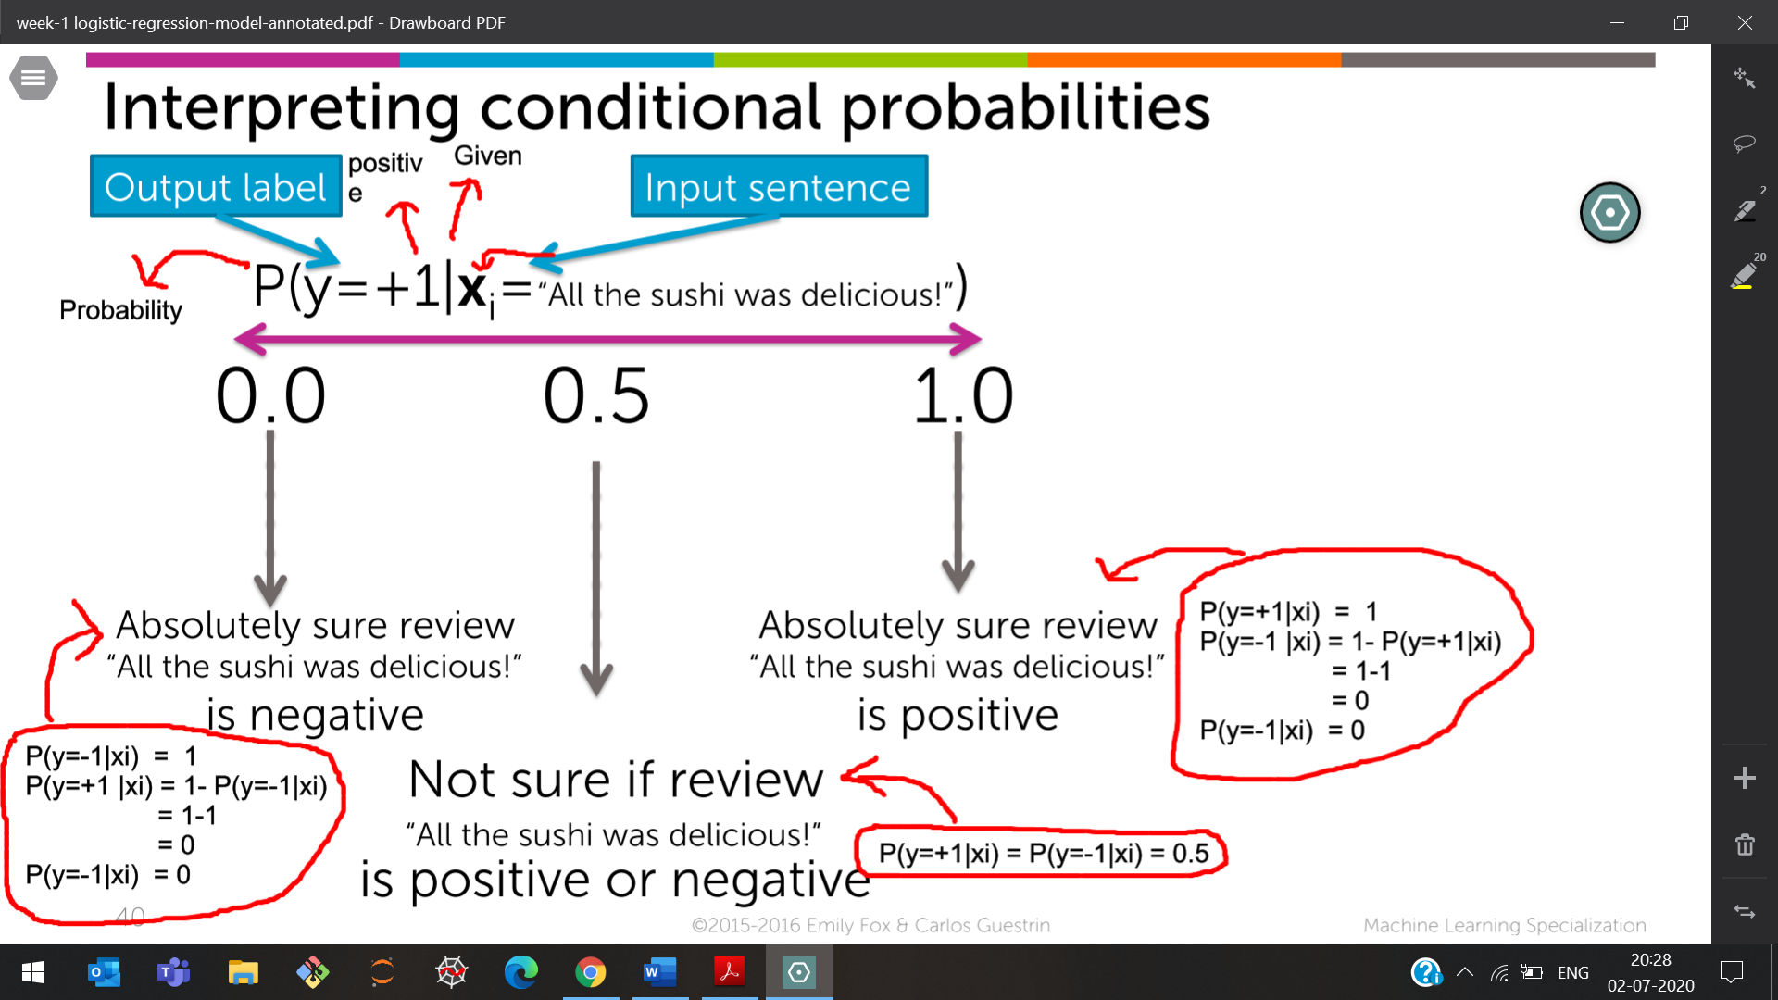

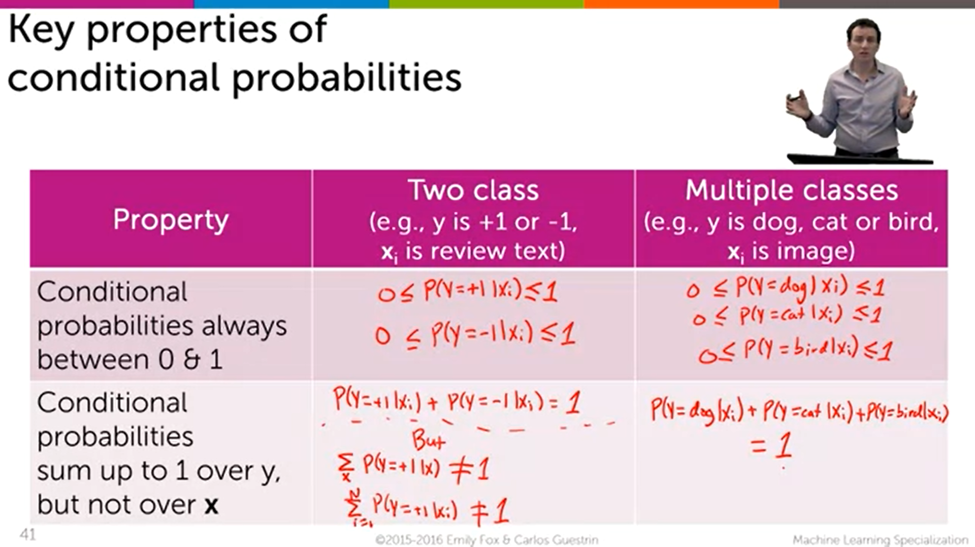

**Probabilities used in Classification**

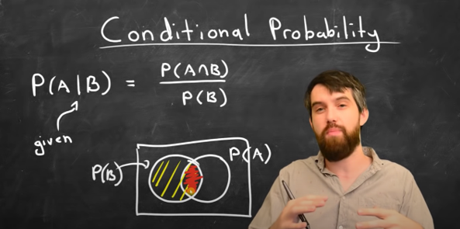

P(A|B) 🡪 The probability of How much A is in B

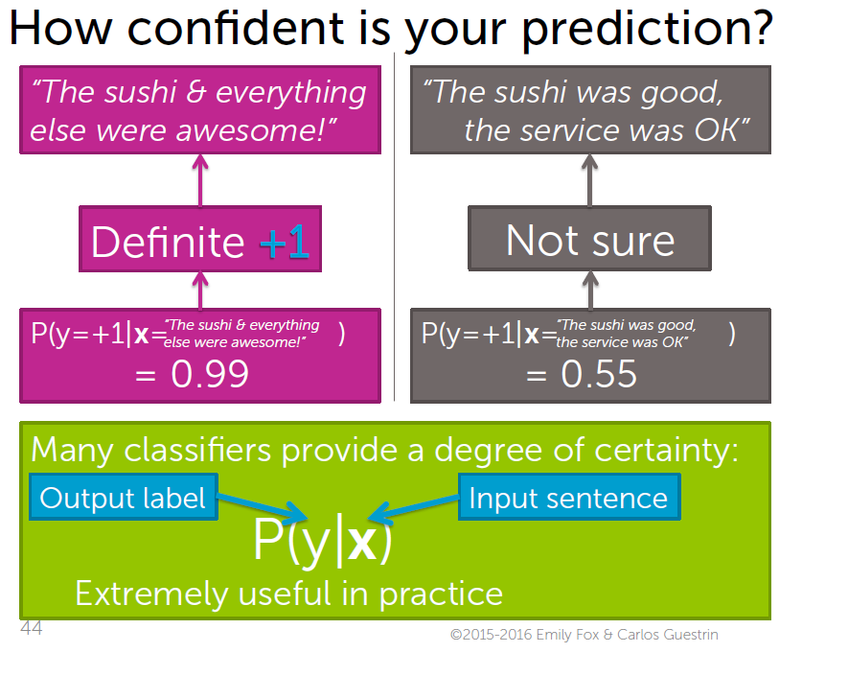

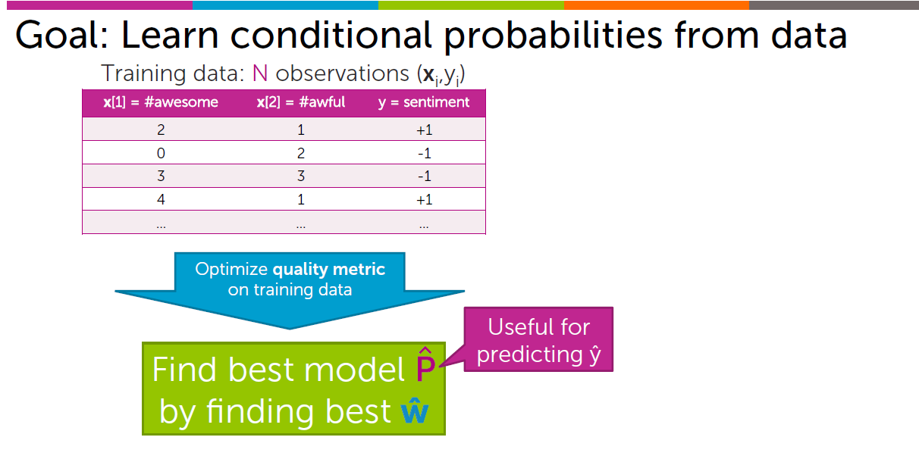

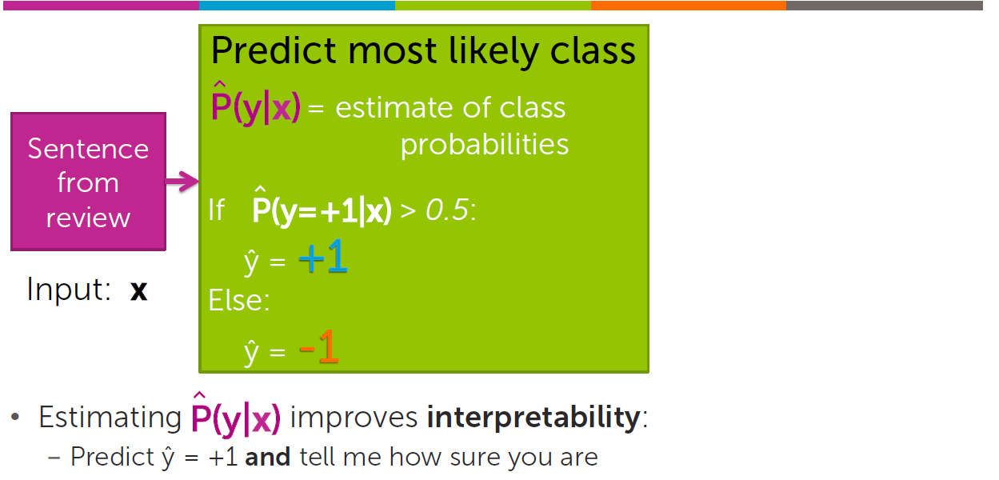

**Logistic Regression**

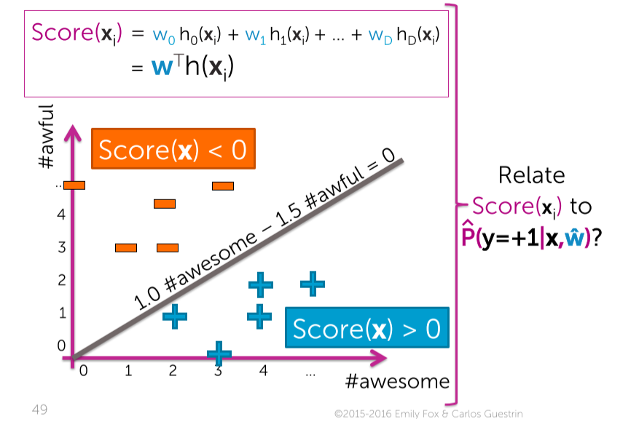  
We know below the line the score(x)>0 and   
above the line the score(x)<0. But we don’t know how much far is it less/greater than 0

1. **Predicting the class probabilities with (generalized) linear model**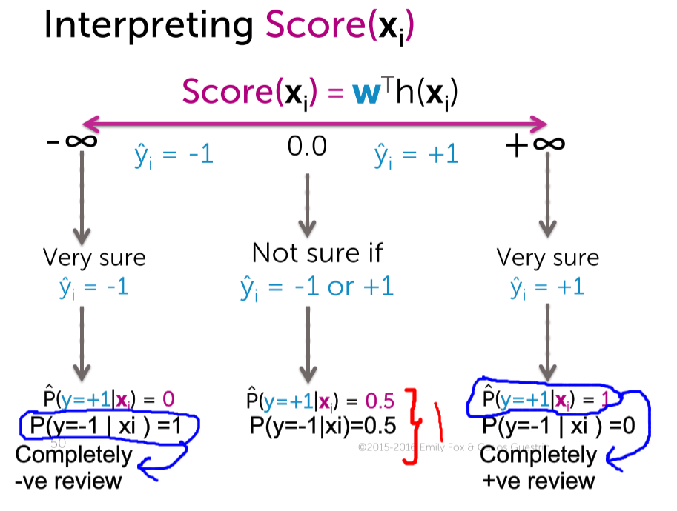

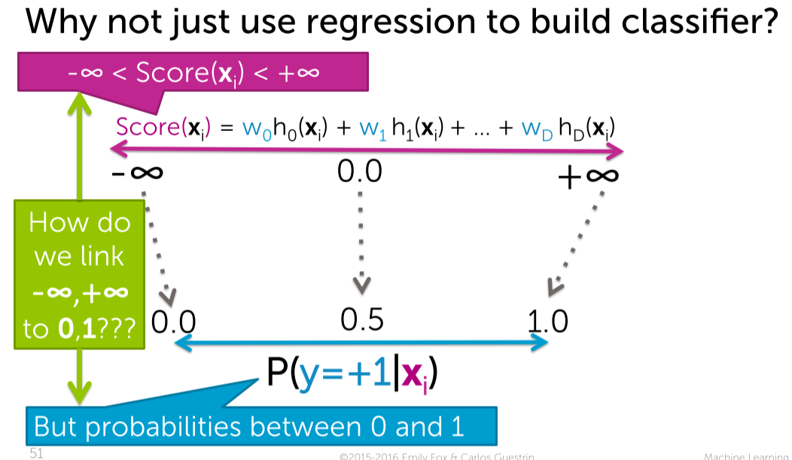

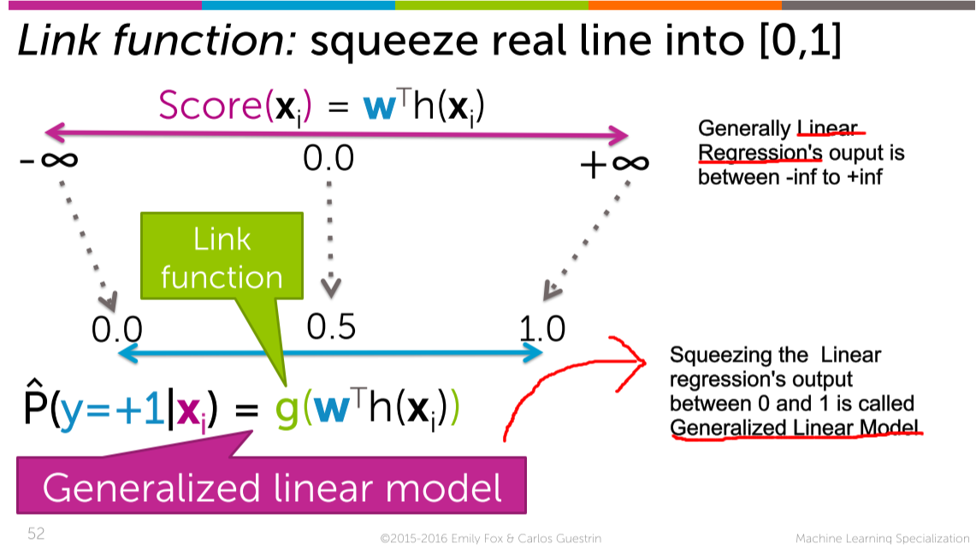

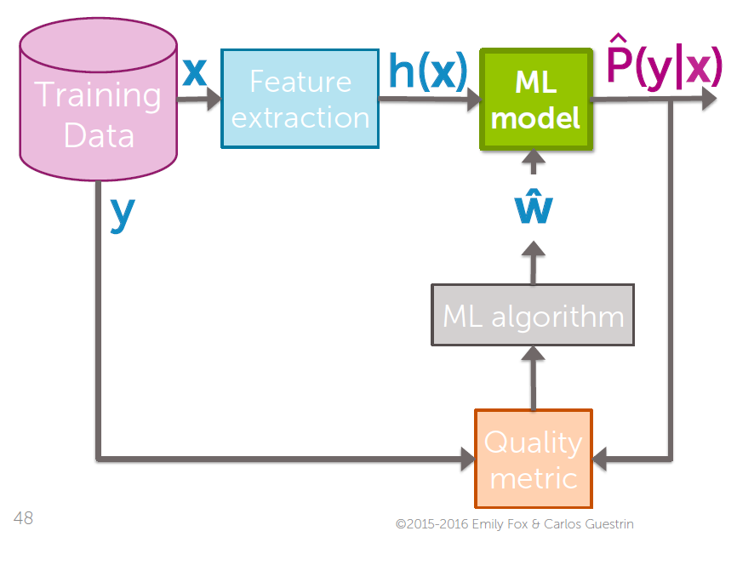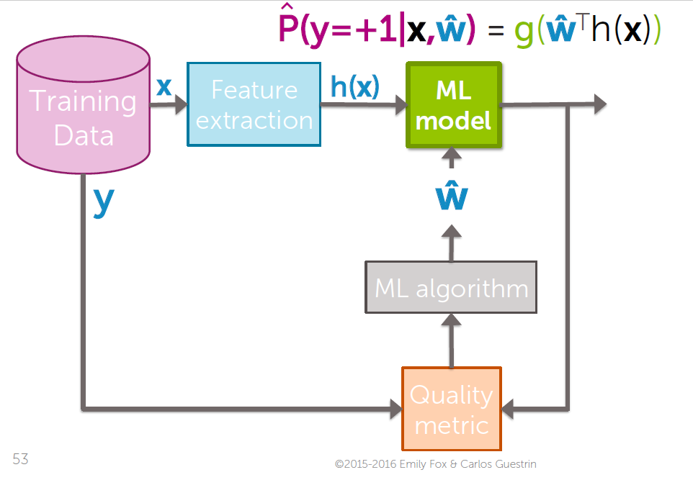

**2) The sigmoid(logistic) Link function**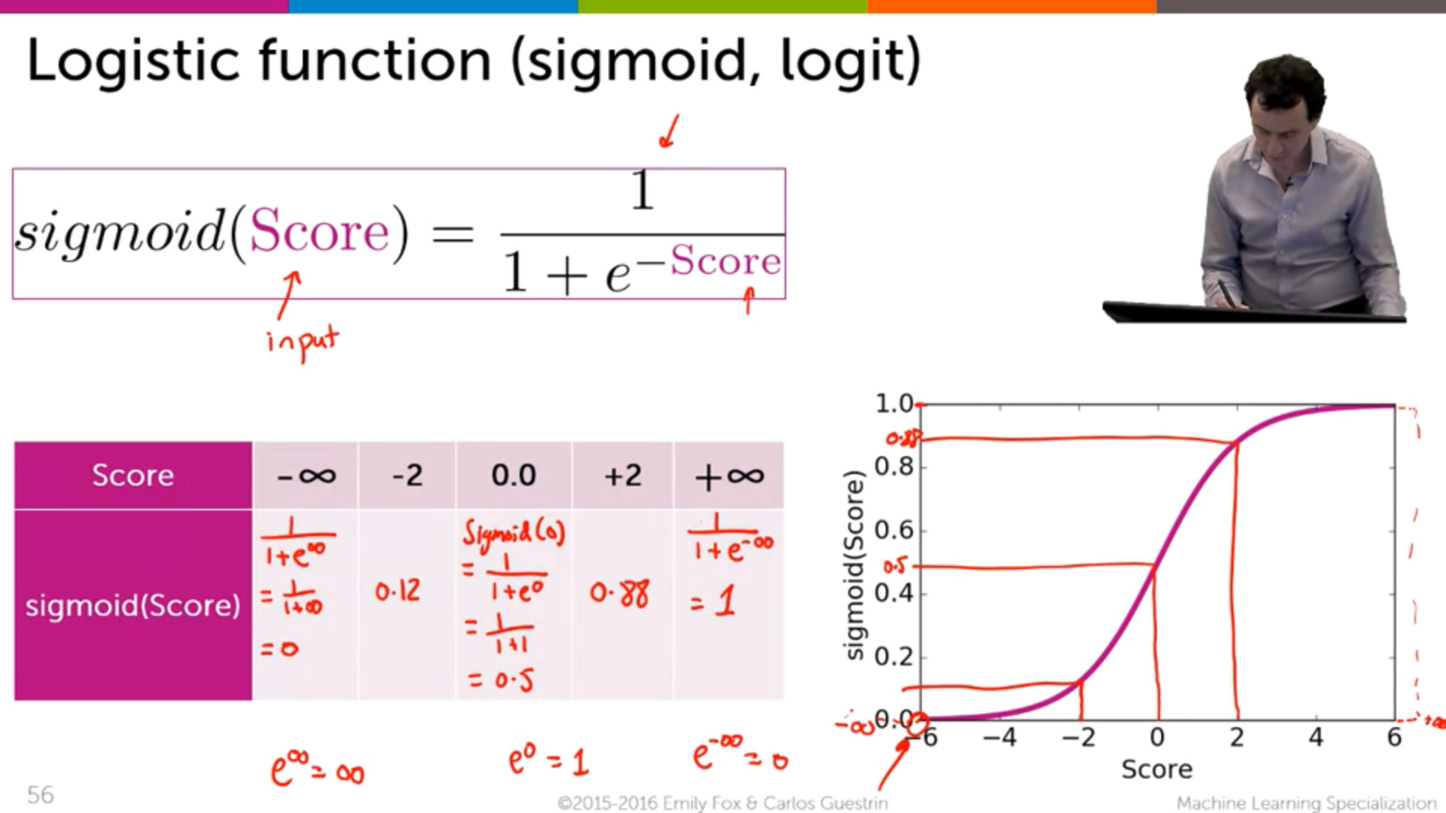

We are giving the score whose output is (-inf to +inf)

Wants to change the output (0 to +inf)

This is done using Link function which is Sigmoid function

**2)Logistic Regression Model**

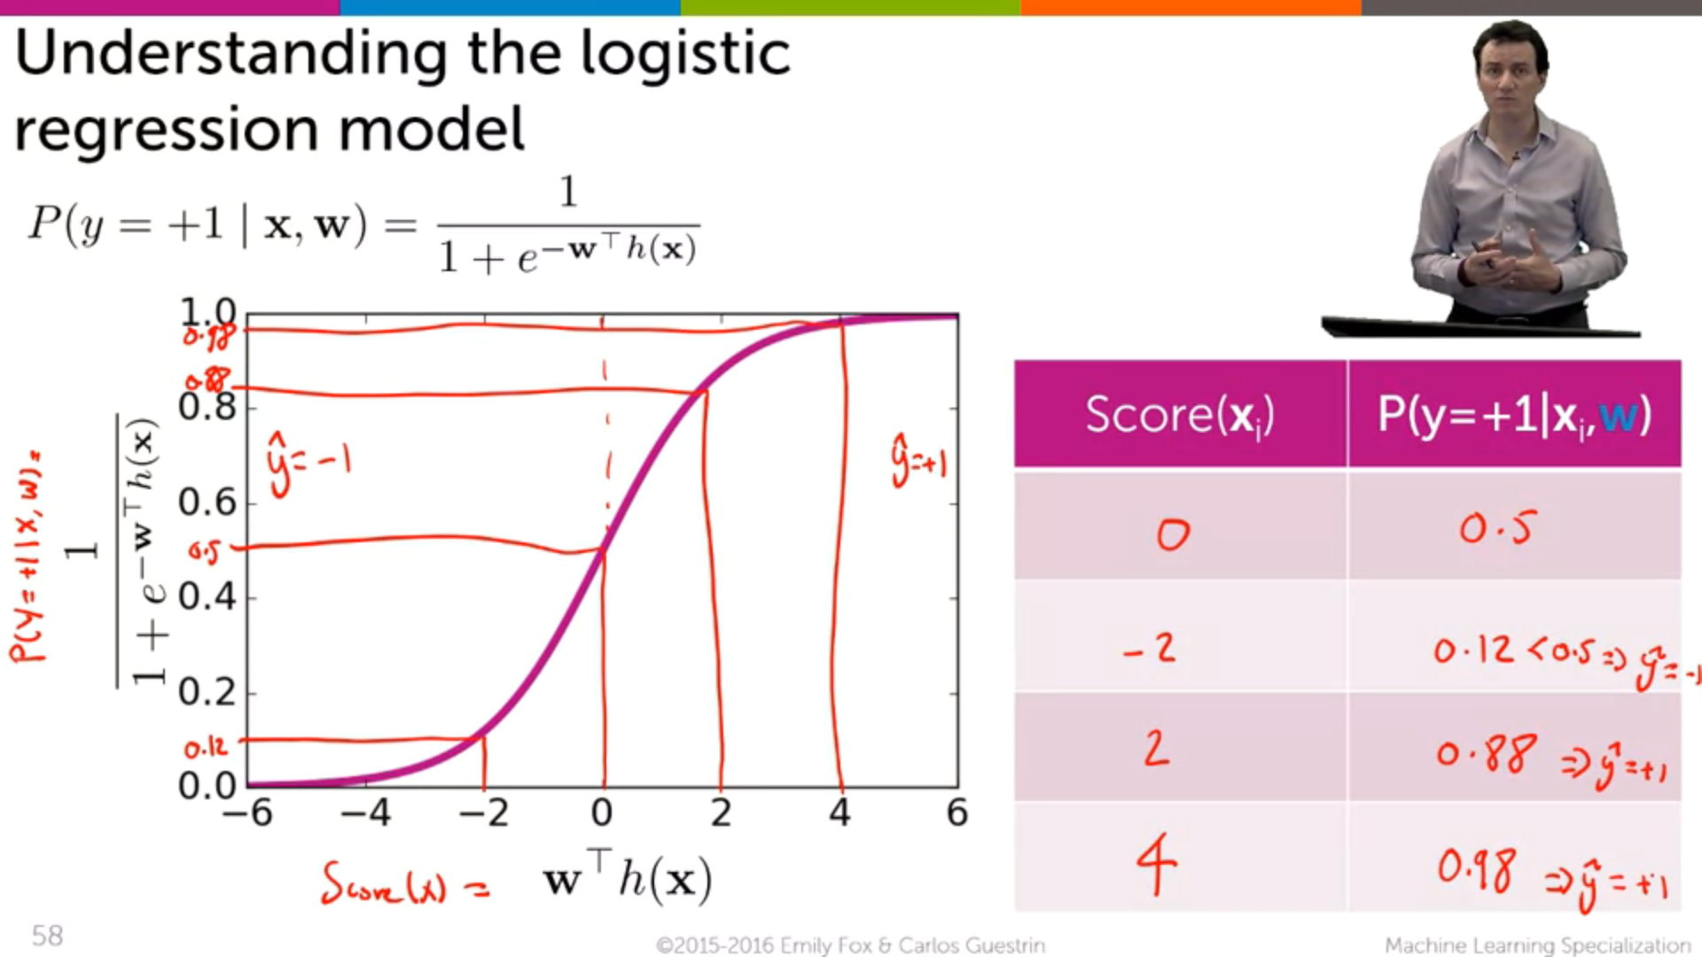



-ve reviews +ve reviews

Taking Score(x-axis) and Probability(y-axis)

**Effect of coefficient values on predicted probabilities**

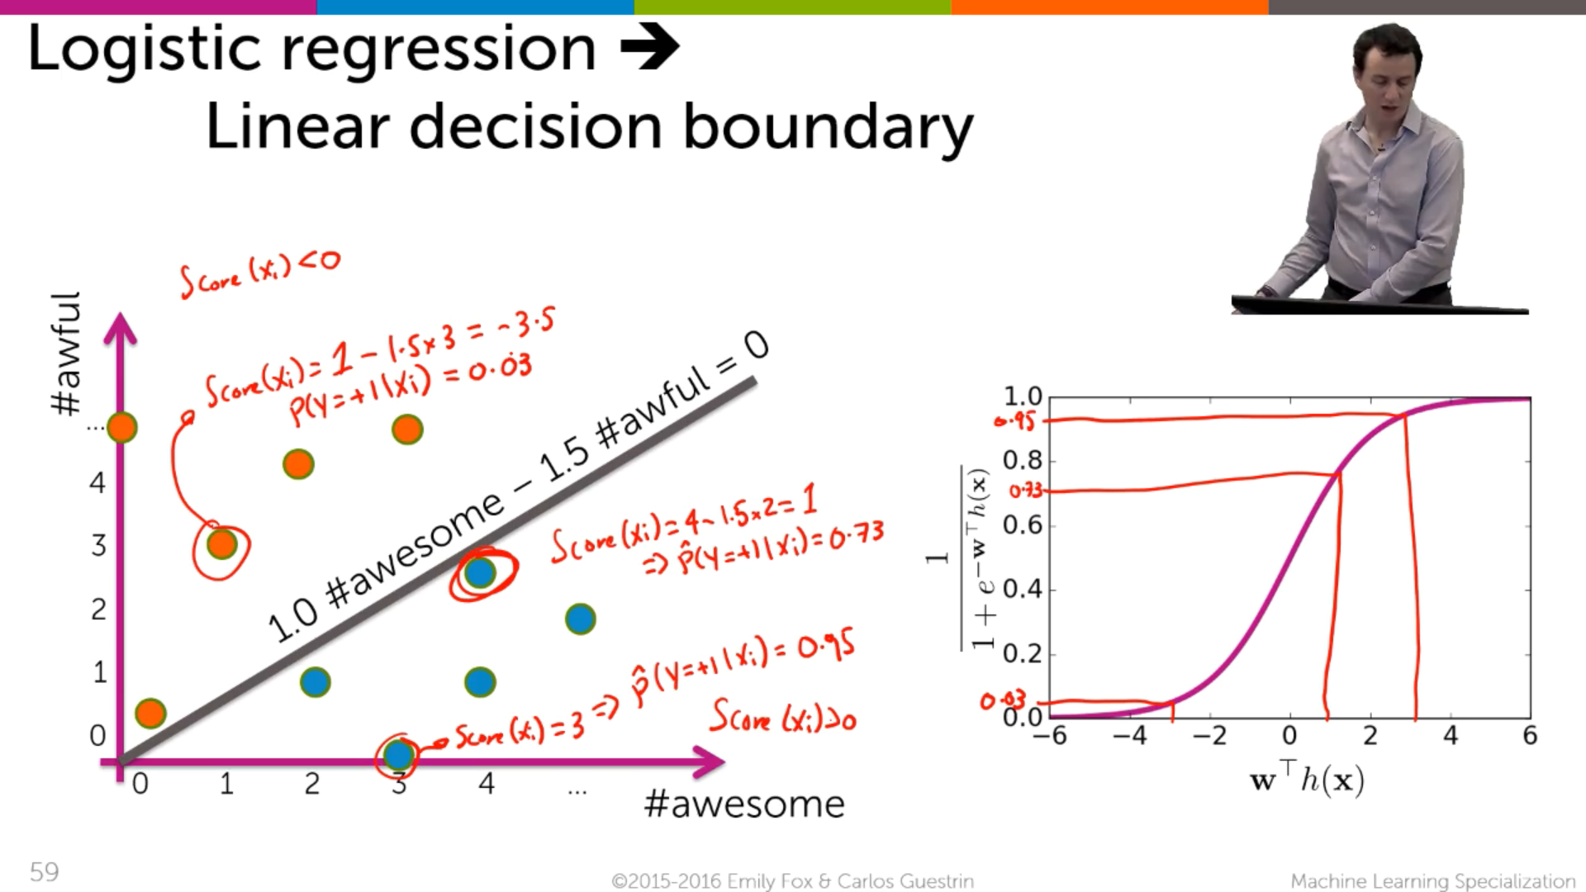



**4) Effect of coefficient on Logistic Regression Model**

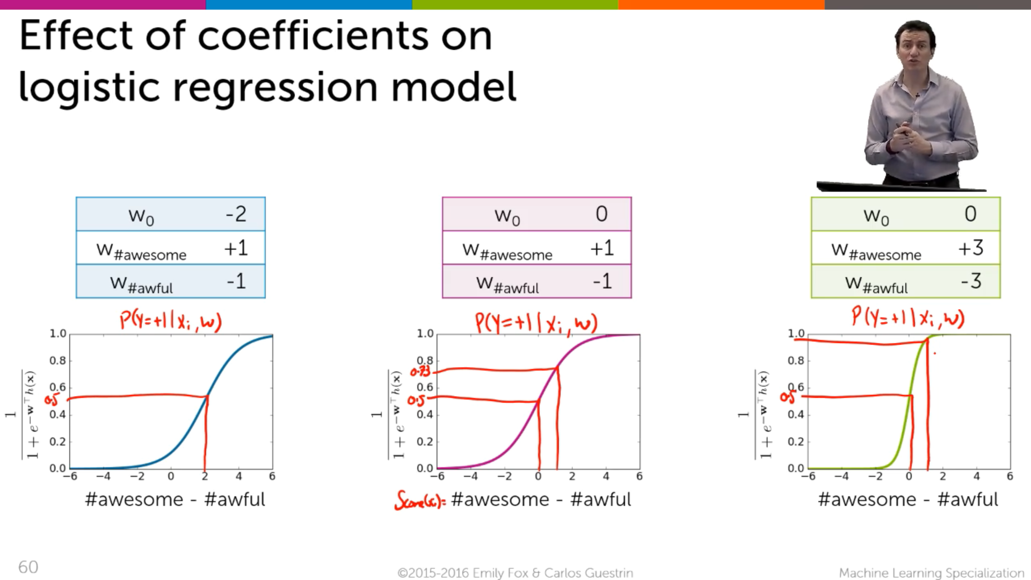



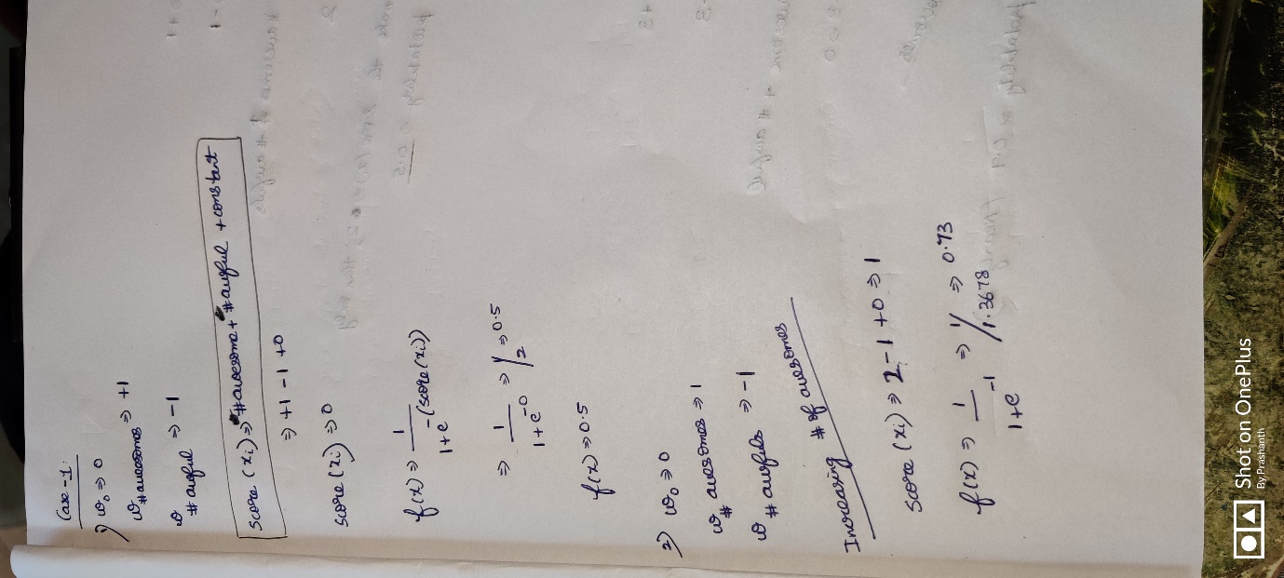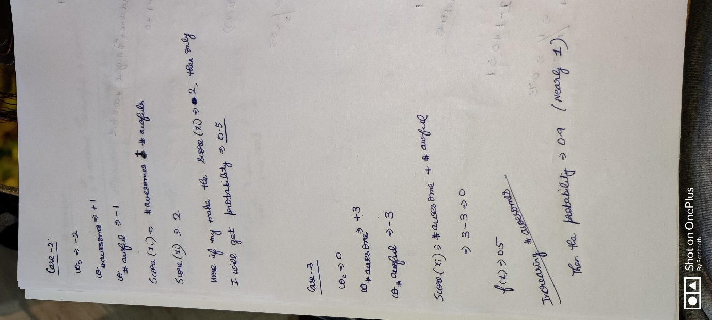



**Conclusion**

* See the effect of coefficients affecting the probability. We can conclude if the model has some bigger coefficients then the probabilities can be found more quickly.
* Changing the constant will shift the line to the left and to the right.

**Now we want to find the coefficients that best fits**

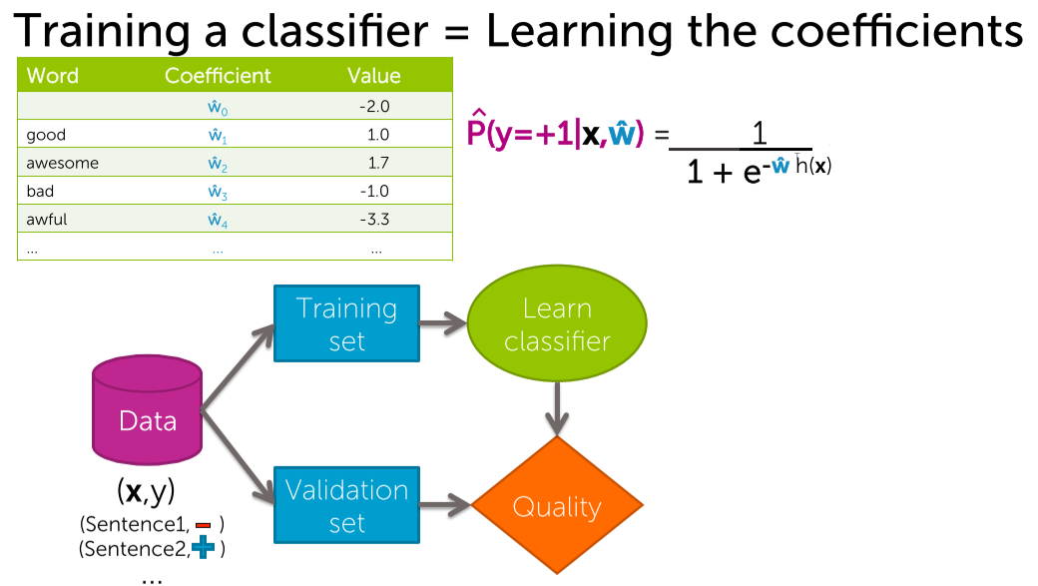

The data is splitted up into training and validation set.   
In training set, running a learning algorithm and output the parameter w^.   
This w^ is fitted into the model, to estimate the probability that the input sentence either +ve (or) -ve.  
Now we can take the validation set and fit into the model . And can predict the quality metric, error etc..

**How to choose w^ ????**

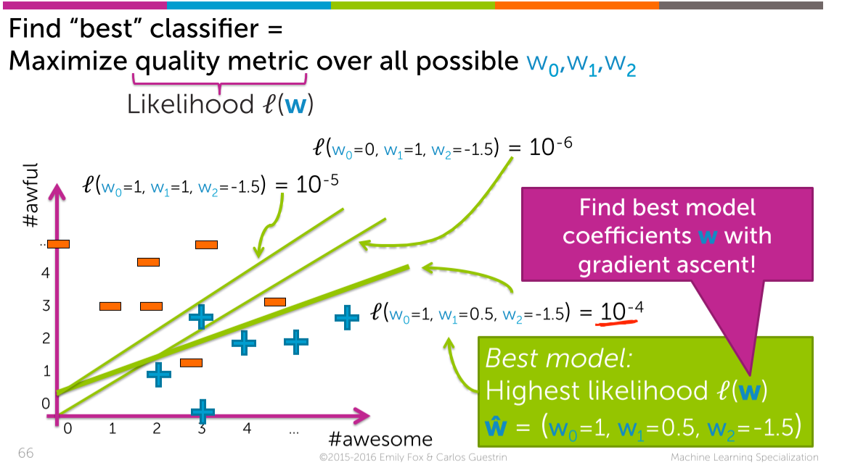



Quality metric 🡪 likelihood function l(w)  
We are saying among the three 10^-4 🡪 best likelihood   
( Since for the best classifier 🡪 Maximise the likelihood l(w) )



We want the required w^, in which l(w) 🡪 maximum. So in-order to choose that w^ gradient ascent comes to the picture.

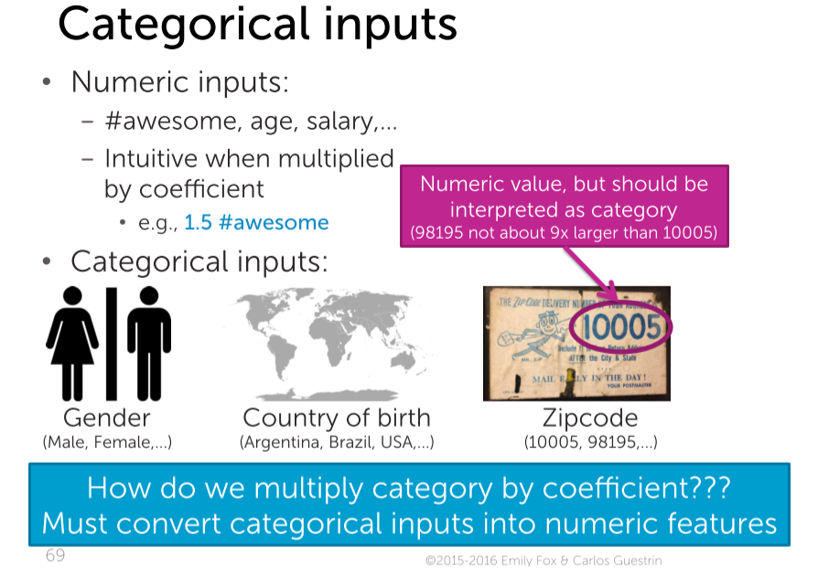

Basically in numerical data,   
in score function 🡪 we will multiply the numeric with the coefficient.

The zip-code is 10005,98195 etc. It is not meant that 98195 is 9 times of 10005. These are different postal codes representing different parts of the country. Hence they are not numerical features, they are categorical features.

But how to multiply the coefficient with the categorical values???  
This is achieved by **encoding technique**

**Encoding Categorical inputs**

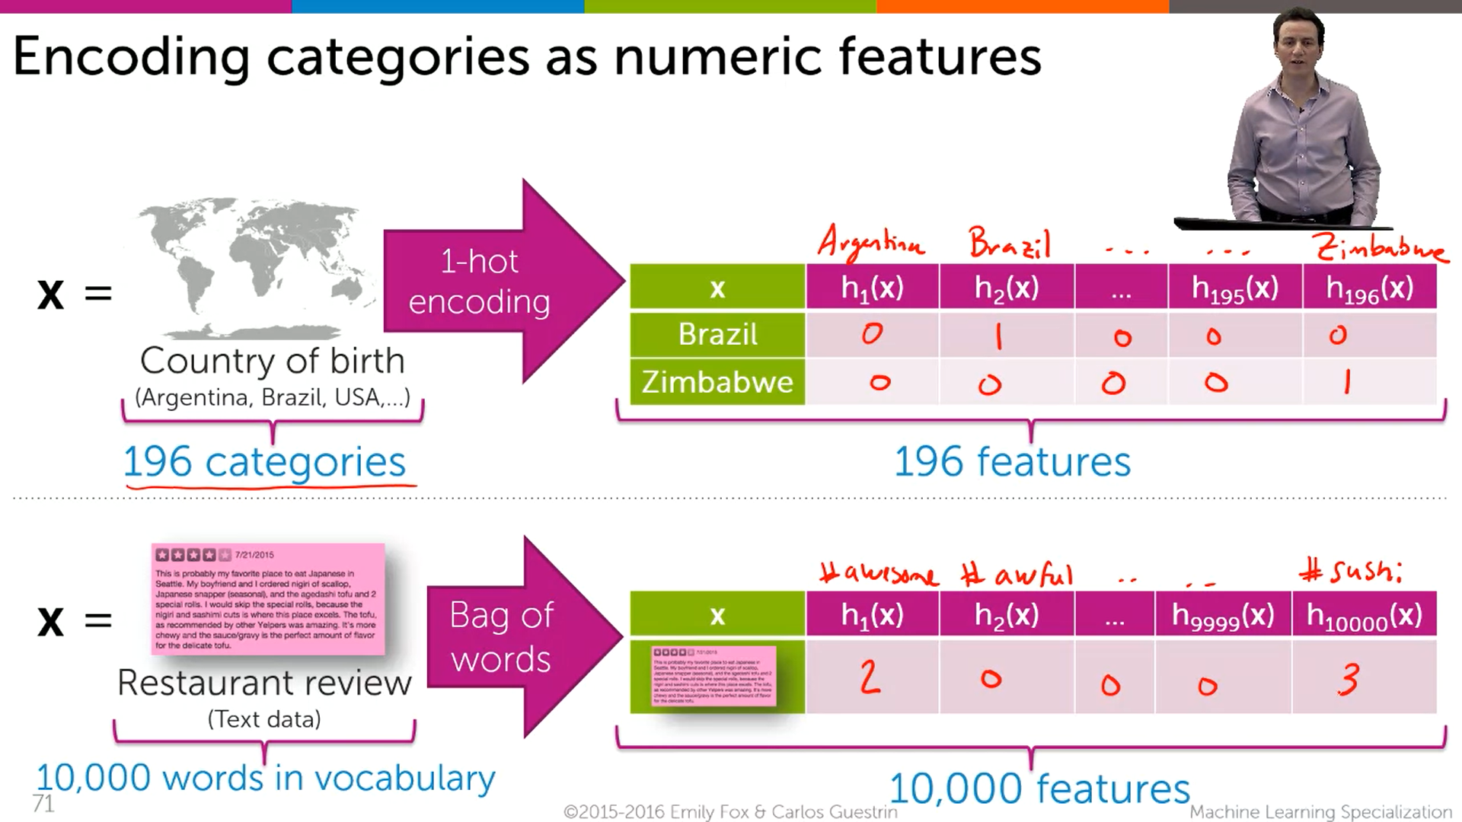



If somebody is born in Brazil 🡪 then for Brazil put 1 and for everything put 0  
If somebody is born in Zimbabwe 🡪 then for Zimbabwe put 1 and for everything put 0



How to encode a restaurant’s review???  
Take 1 review, and put down the word count in the respective places  
In the above case , 1st review contains (2 🡪 awesome) , (0 🡪 awful) ,…,(3🡪sushi)

**Multiclass classification (1 versus all)**

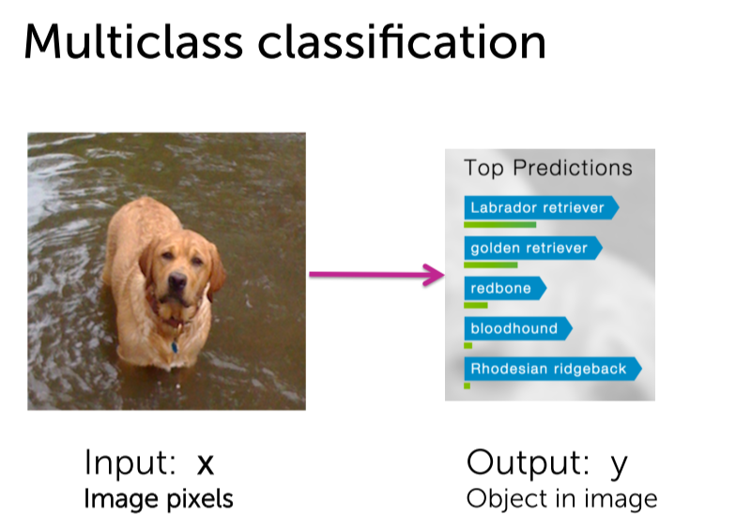

In this image 🡪 there is a dog  
Our aim is to predict 1) Whether is it a dog ?? 2) What kind of dog is it???  
Here we are not having only 2 categories . There a nearly 1000’s of categories.

**How to solve this??? 🡪 One versus ALL**

Eg: Triangle, donut and hearts are different classes

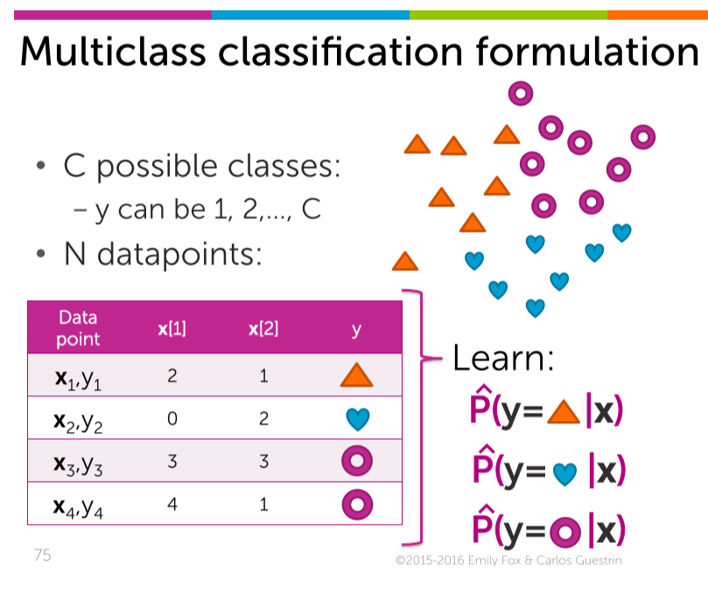

There are 3 classes,

What I need to know is for a particular input, whether is it a triangle, hearts or donut.

Now I want to classify the triangle from the rest

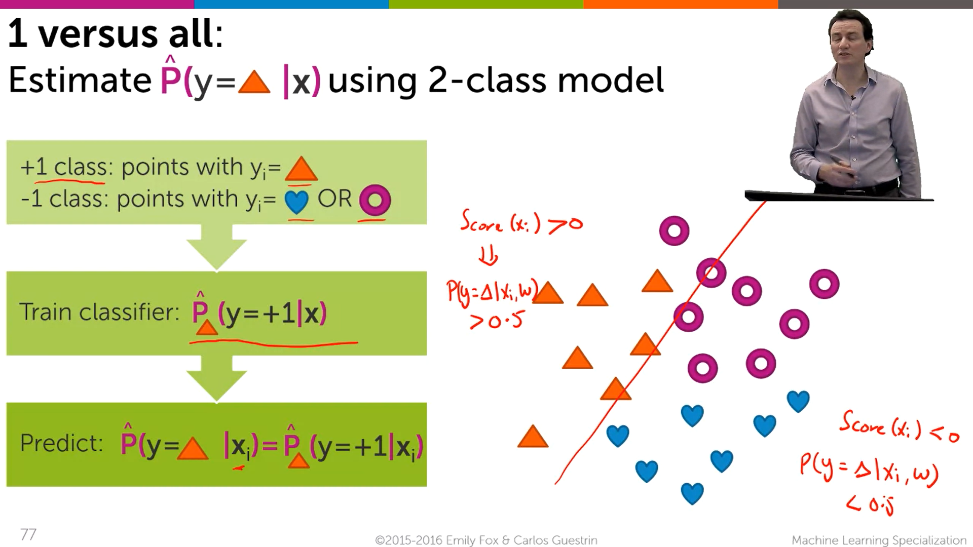



Now we are going to make a classifier to learn 🡪 that separates the triangle from the donuts and hearts. This train classifier outputs +1, if the input x is more likely to be a triangle.

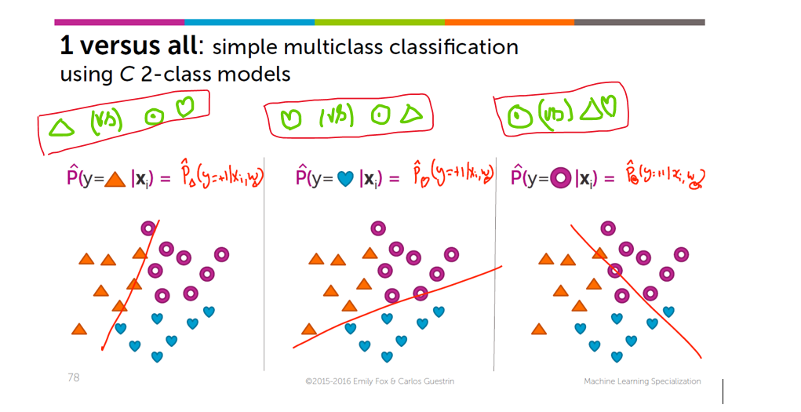

In the same data-set

1st  classifier 🡪 triangle . Note down the probability

2nd classifier -> hearts. Note down the probability

3rd classifier -> donot . Note down the probability

Among these three classifier , capture a classifier which has the highest probability. For eg: If the 2nd classifier (i.e heart classifier) has the highest probability means that classifier ( i.e w (heart) ) make the classification more exact and accurate.

**Take the dog classification example**

Iterate over all the classifier and finally note which classifier has the highest probability and that classifier classifies correctly when compared to the rest of the classifer.

